Screenshots of

Foodbox Applications

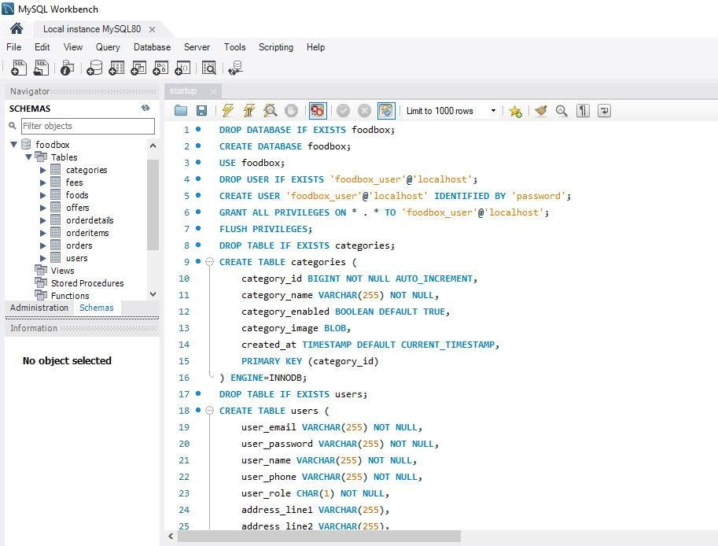

*Figure 1 MySQL Script*

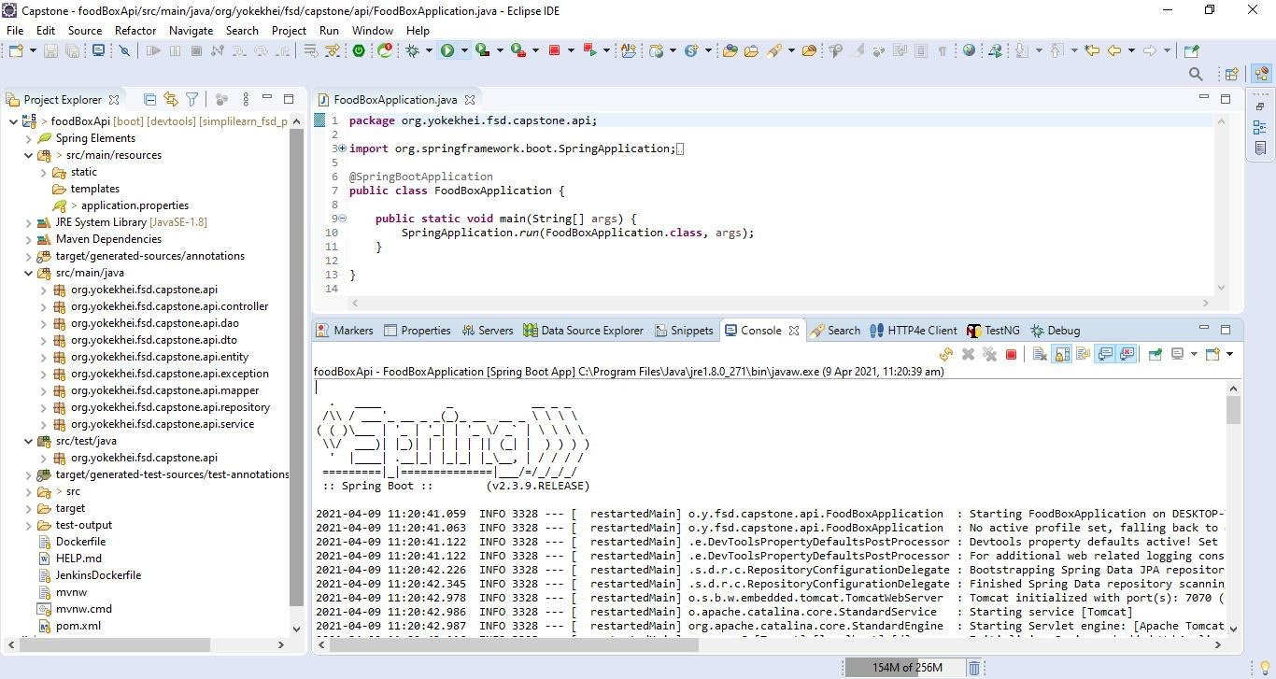

*Figure 2 Eclipse IDE and Foodbox Spring Boot Project for Backend REST APIs Application*

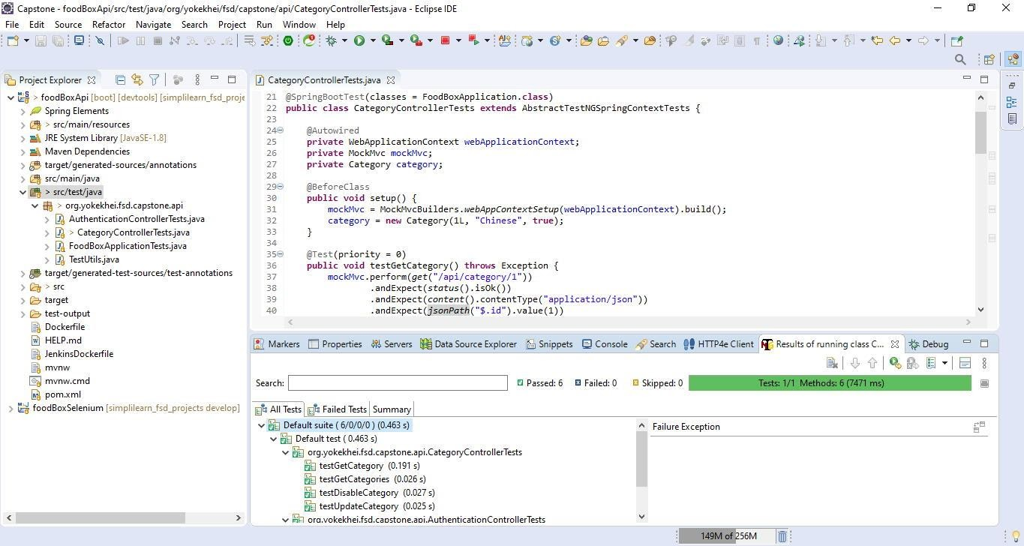

*Figure 3 Foodbox Backend Unit/Integration Tests*

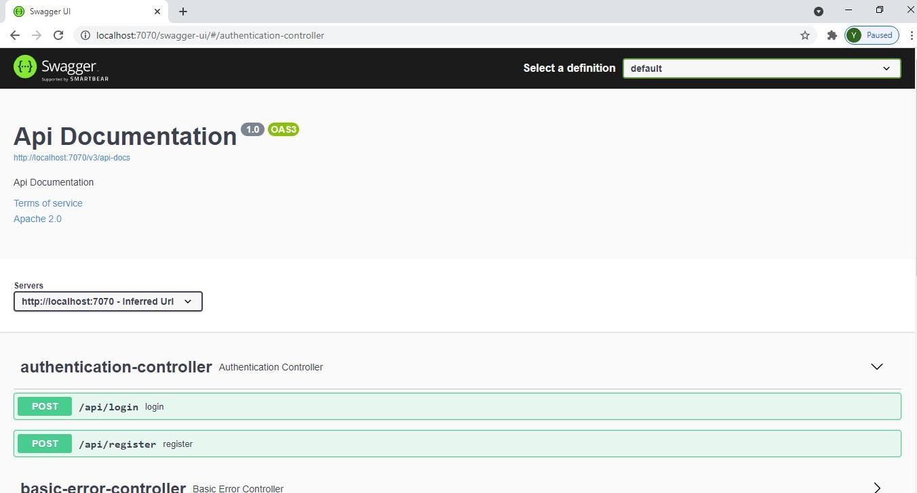

*Figure 4 Swagger UI*

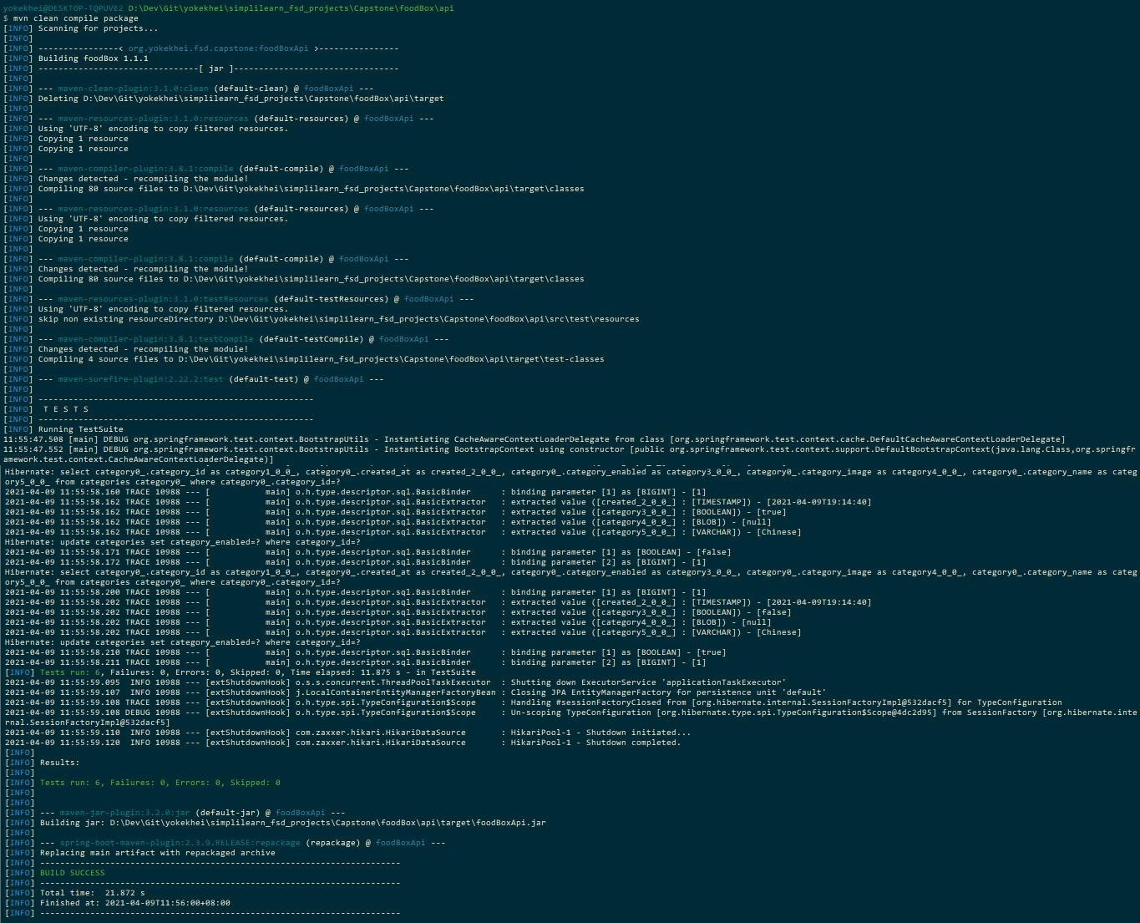

*Figure 5 Maven Compilation and Packaging for foodBoxApi-0.0.1.jar*

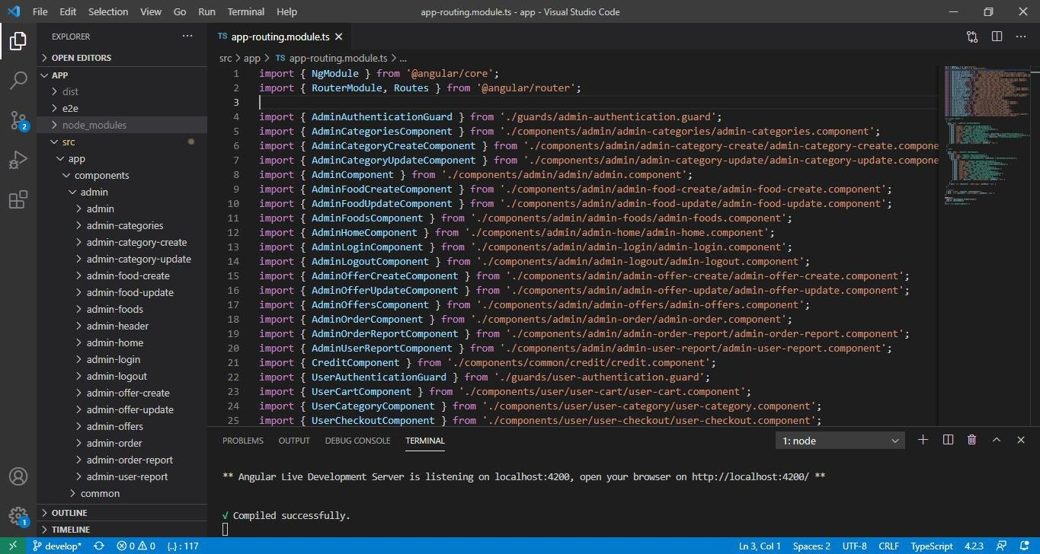

*Figure 6 Visual Studio Code IDE and Foodbox Angular Project for Frontend Web Application*

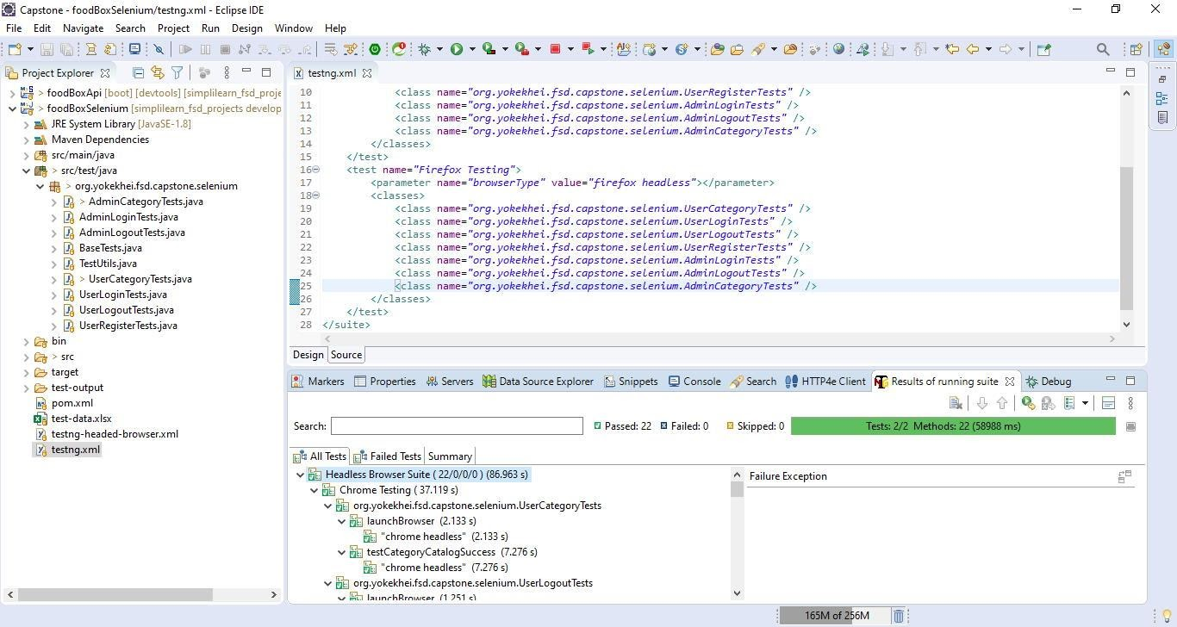

*Figure 7 Selenium Tests Maven Eclipse Project*

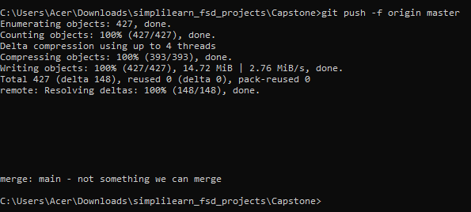

*Figure 8 Local Git Repository*

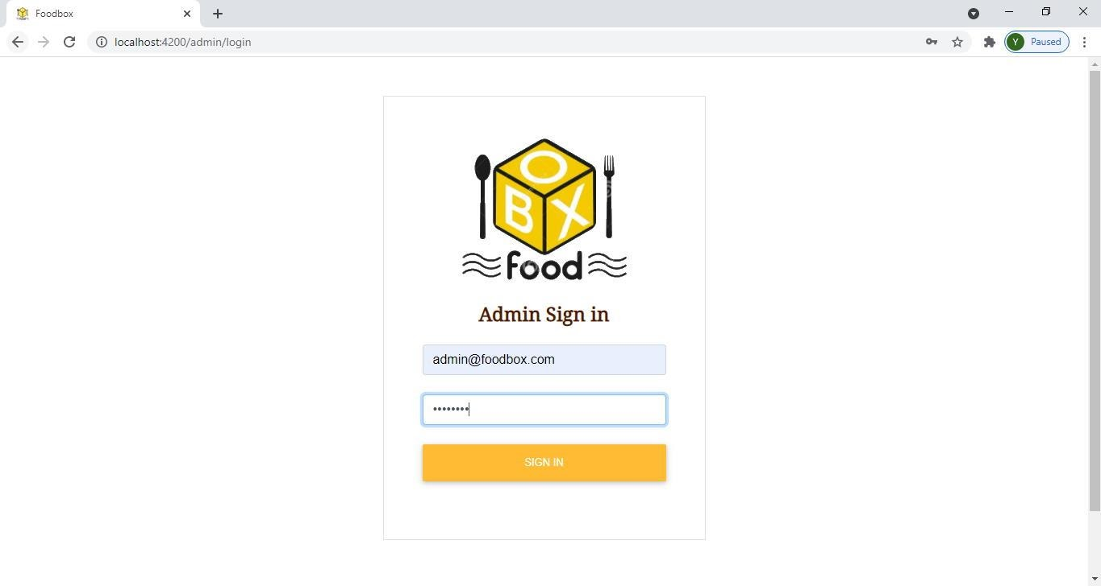

*Figure 9 Admin – Login*

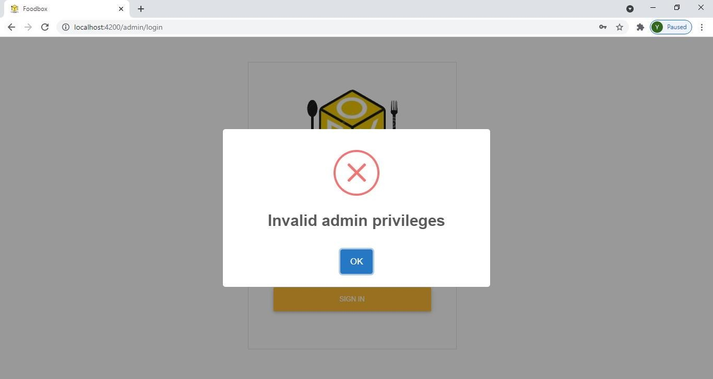

*Figure 10 Admin - Login Failure*

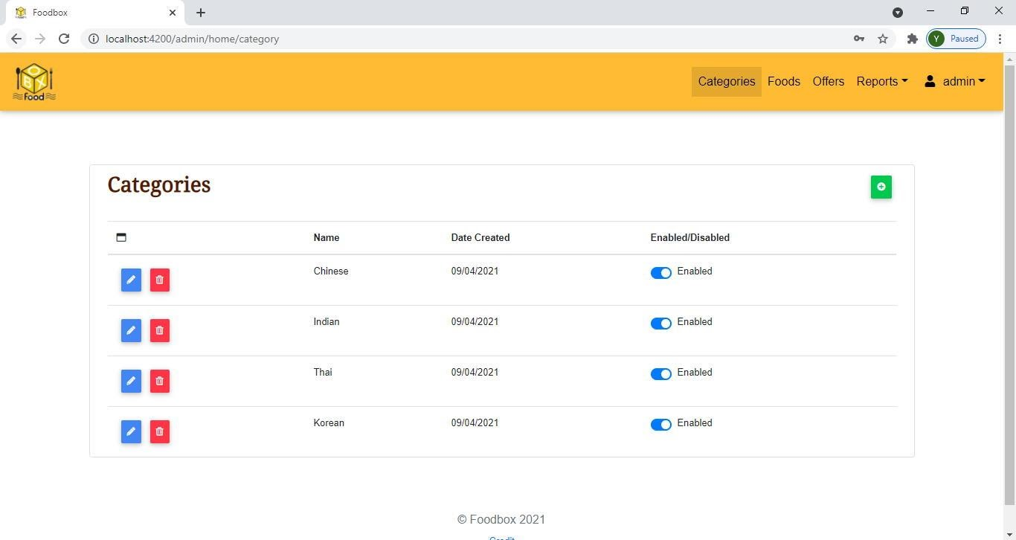

*Figure 11 Admin – Categories*

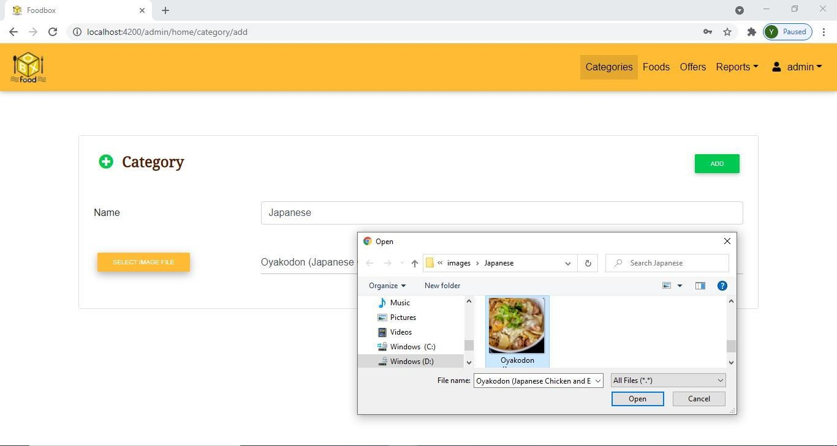

*Figure 12 Admin - Add Category*

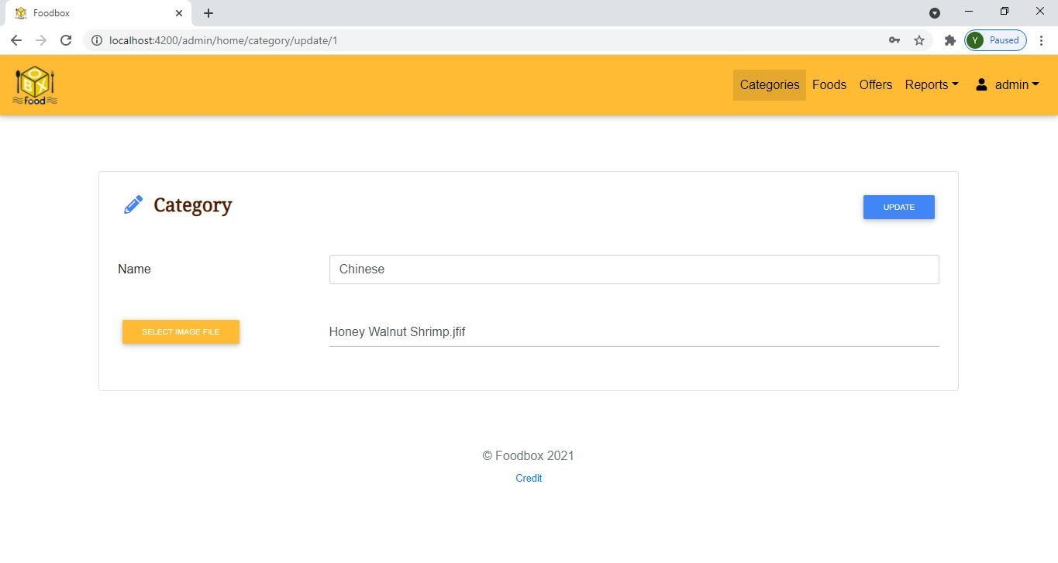

*Figure 13 Admin - Update Category*

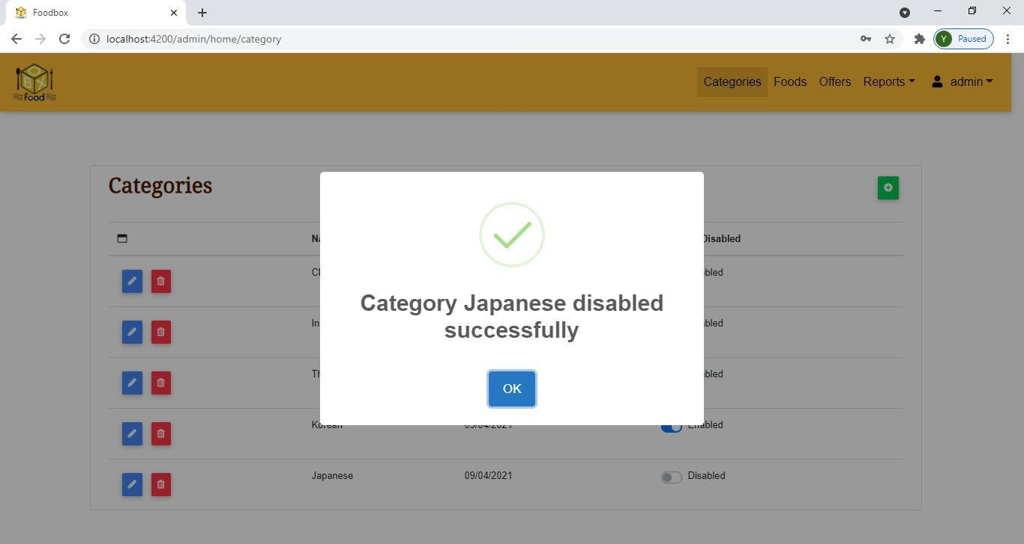

*Figure 14 Admin - Disable Category*

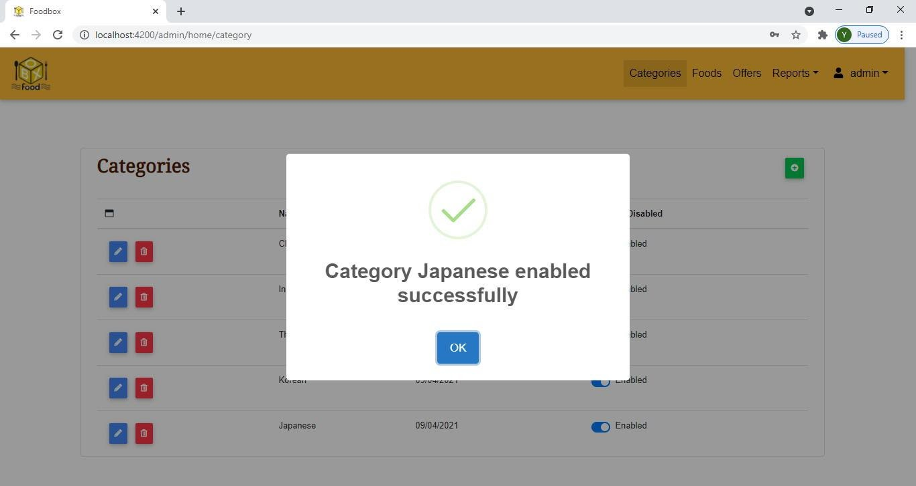

*Figure 15 Admin - Enable Category*

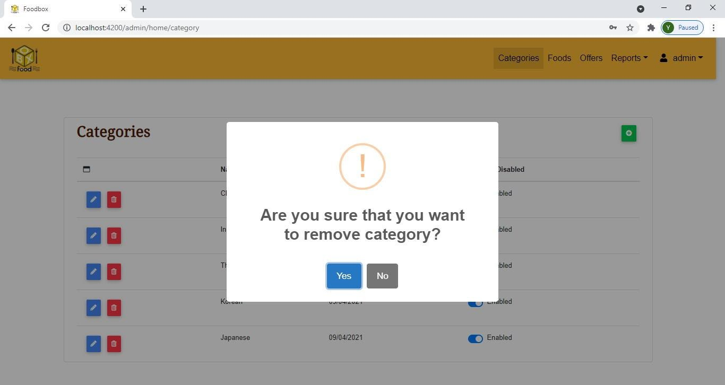

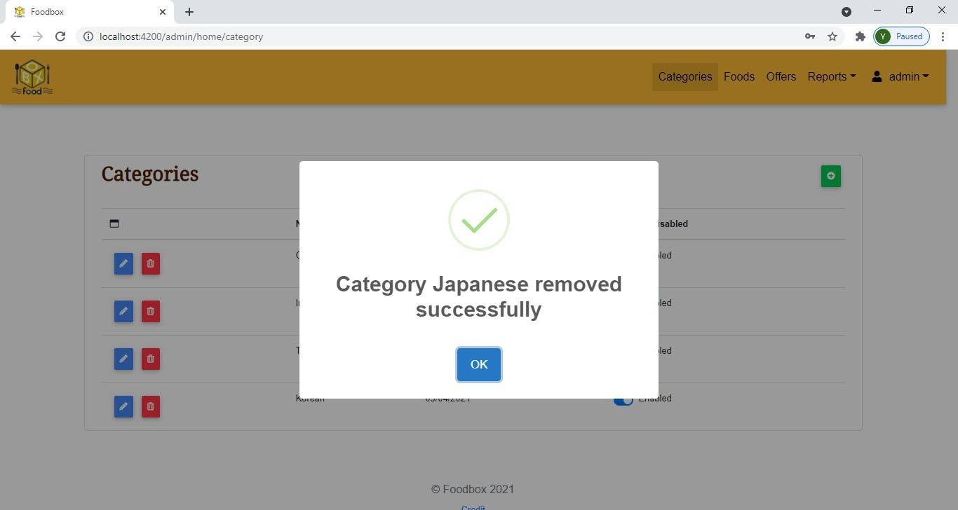

*Figure 16 Admin - Delete Category*

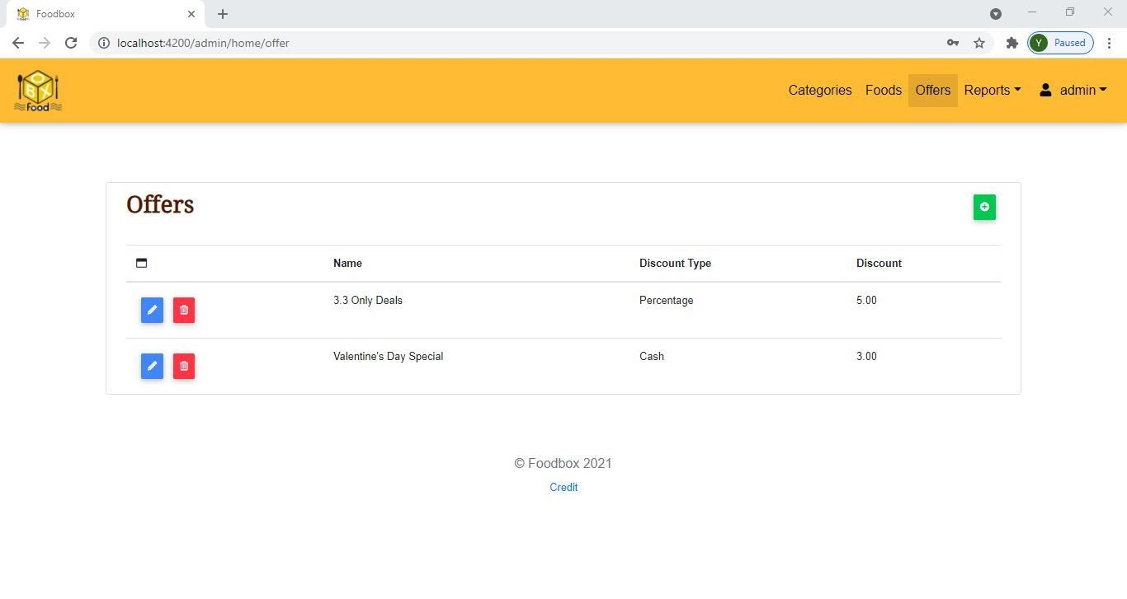

*Figure 17 Admin – Offers*

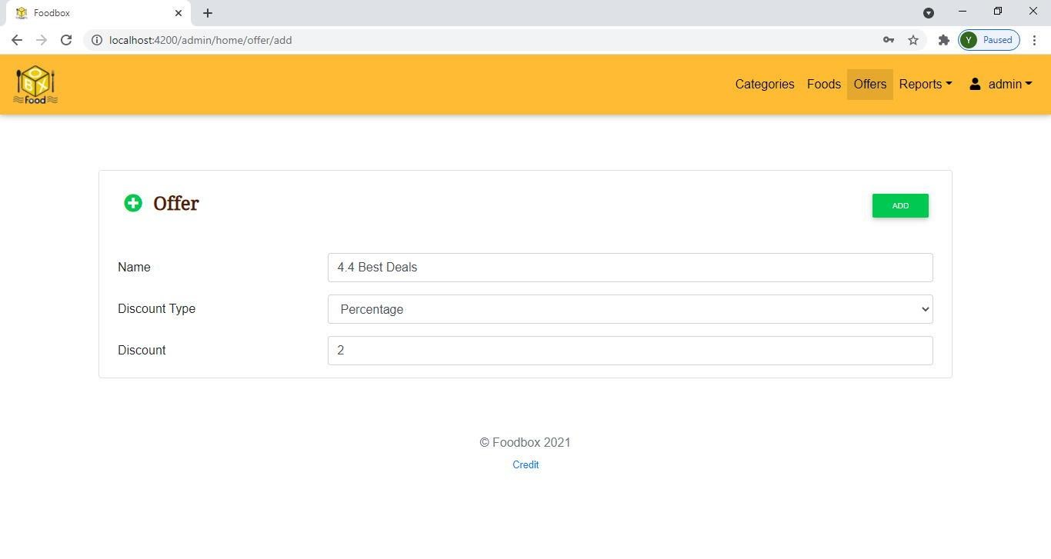

*Figure 18 Admin - Add Offer*

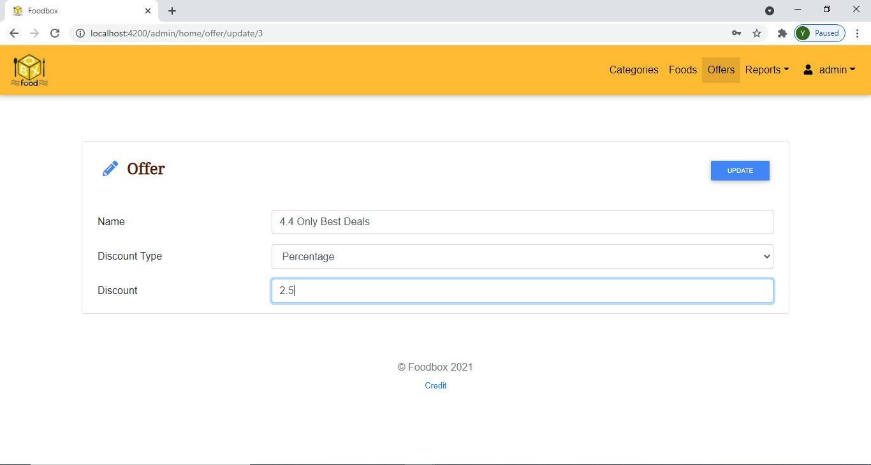

*Figure 19 Admin - Update Offer*

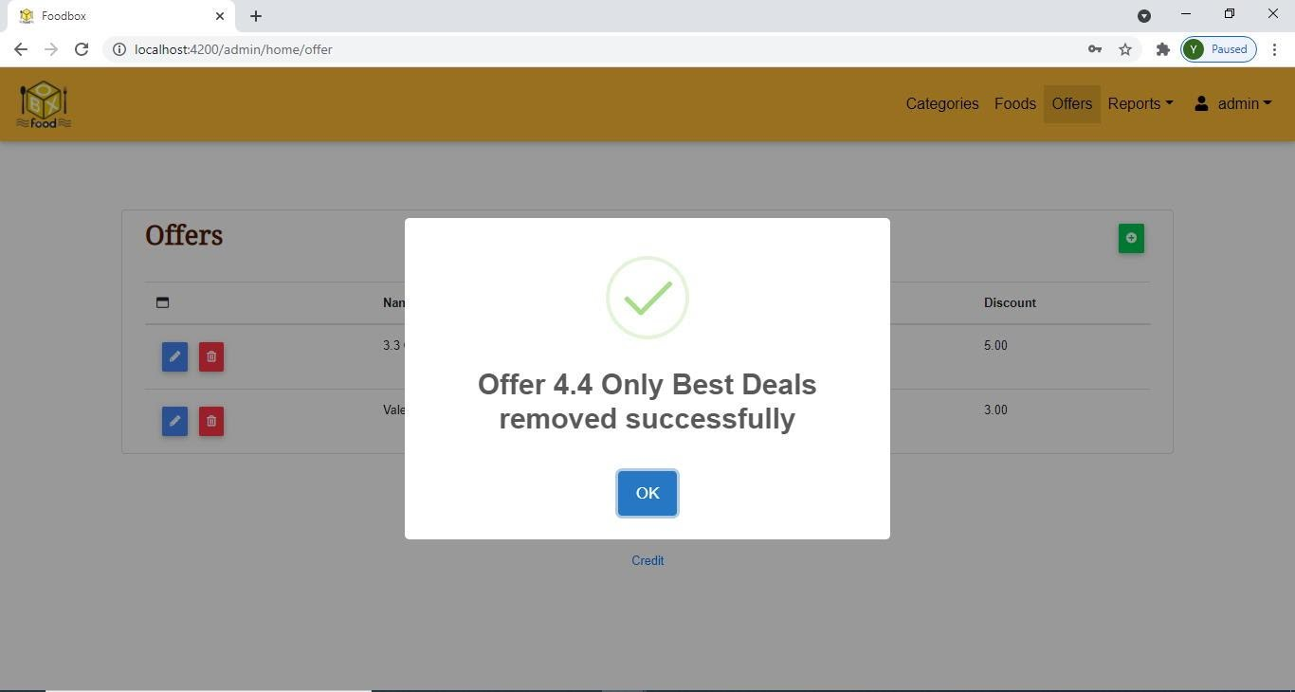

*Figure 20 Admin - Delete Offer*

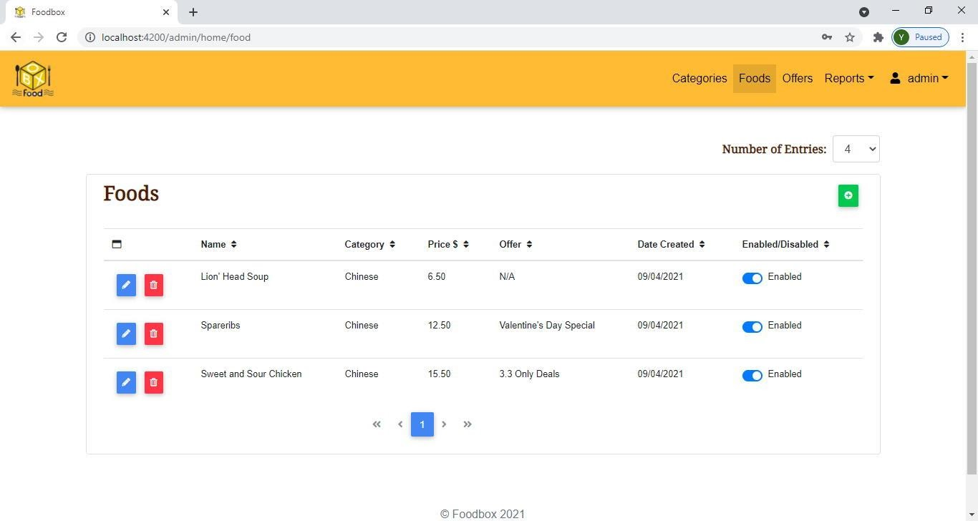

*Figure 21 Admin – Foods*

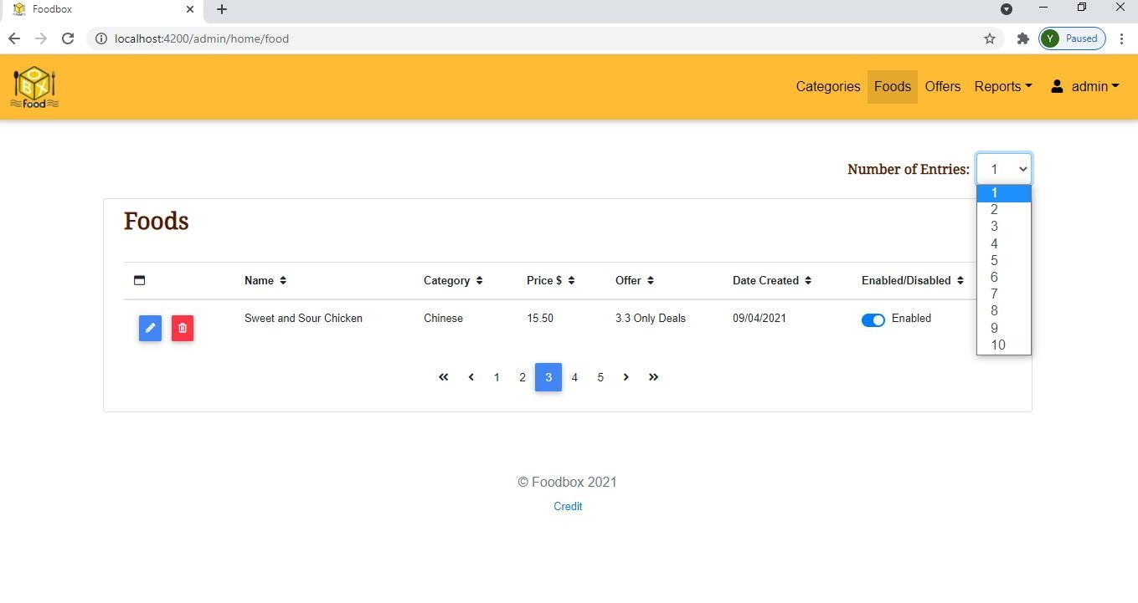

*Figure 22 Admin - Foods Displayed by Pagination*

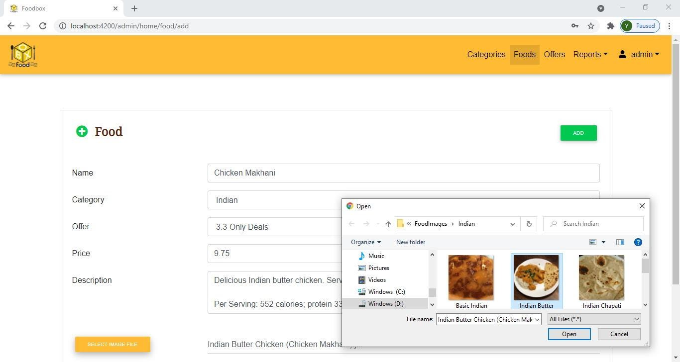

*Figure 23 Admin - Add Food*

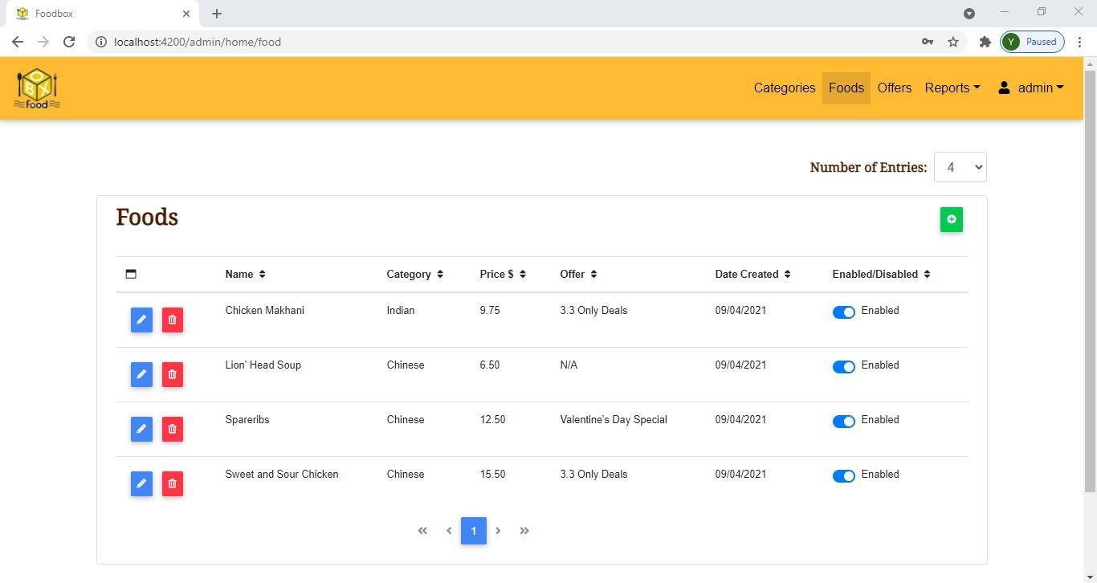

*Figure 24 Admin - Foods Sorted by Name*

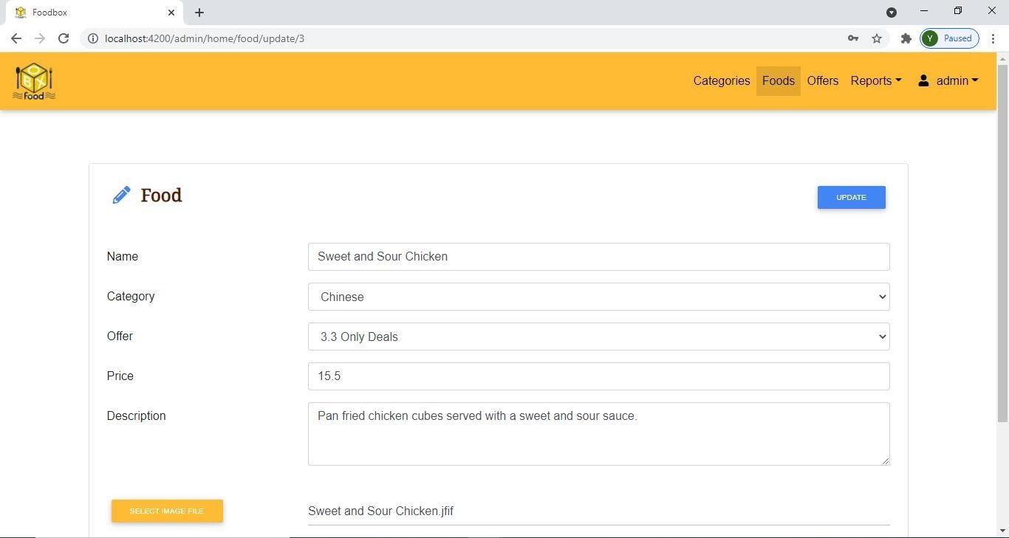

*Figure 25 Admin - Update Food*

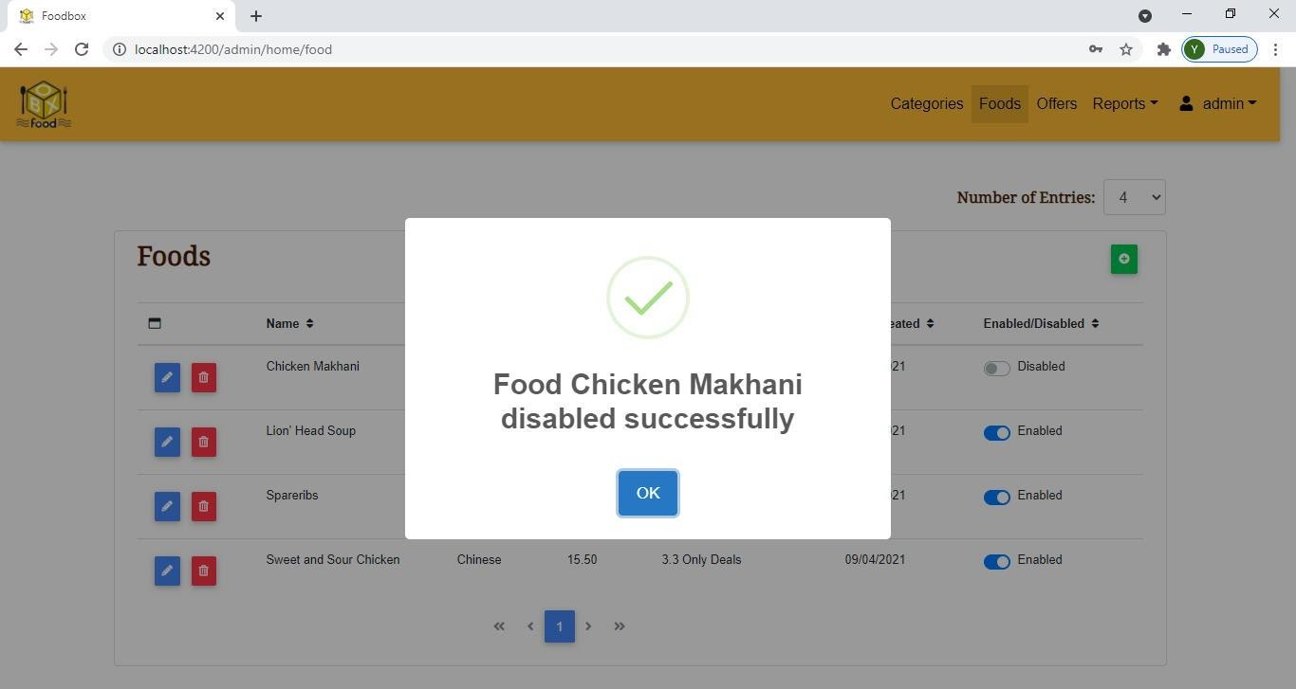

*Figure 26 Admin - Disable Food*

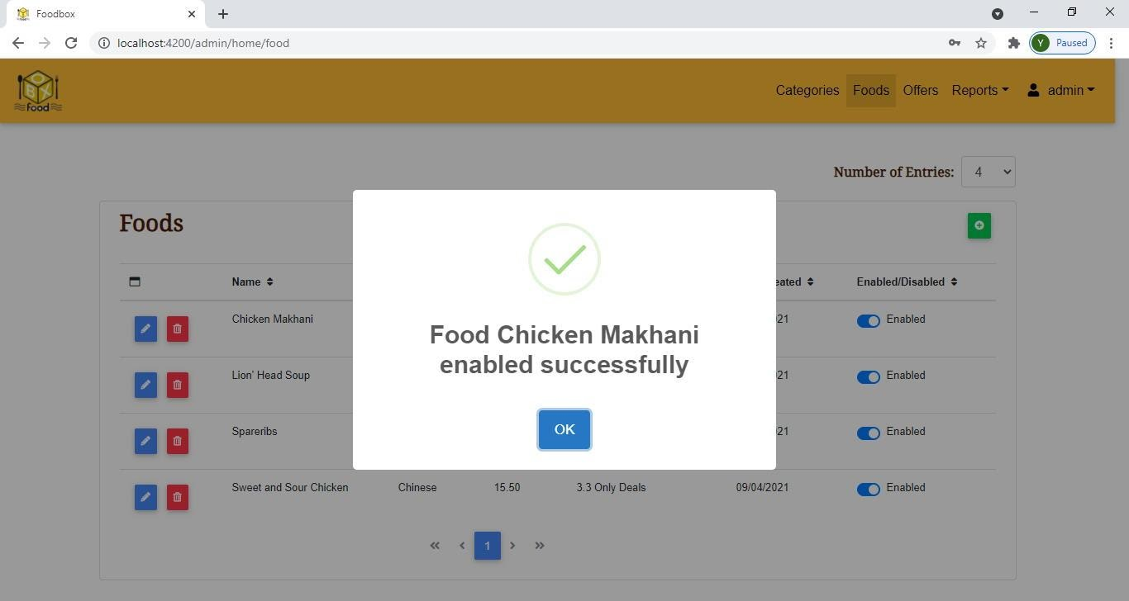

*Figure 27 Admin - Enable Food*

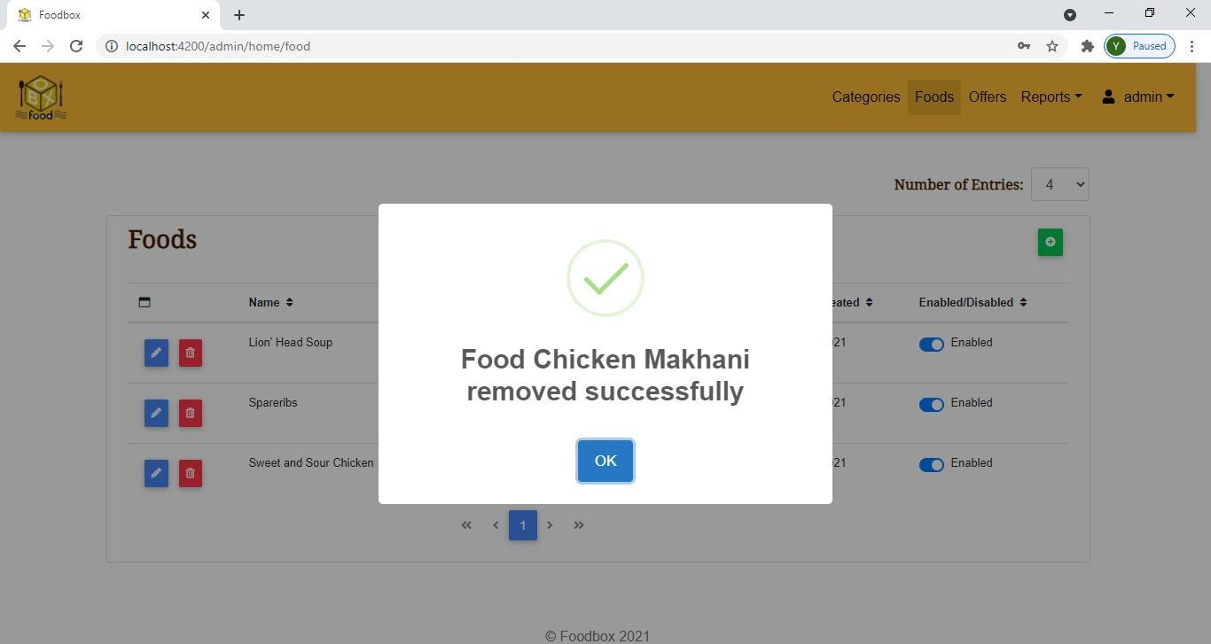

*Figure 28 Admin - Delete Food*

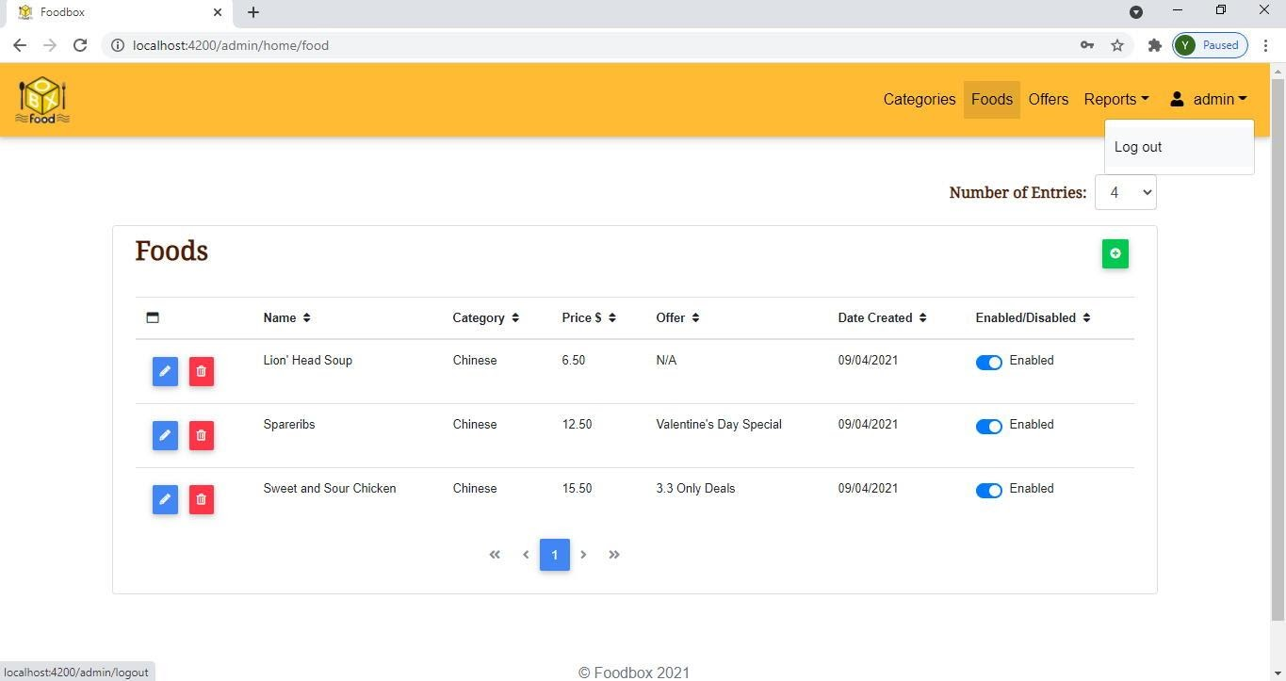

*Figure 29 Admin – Logout*

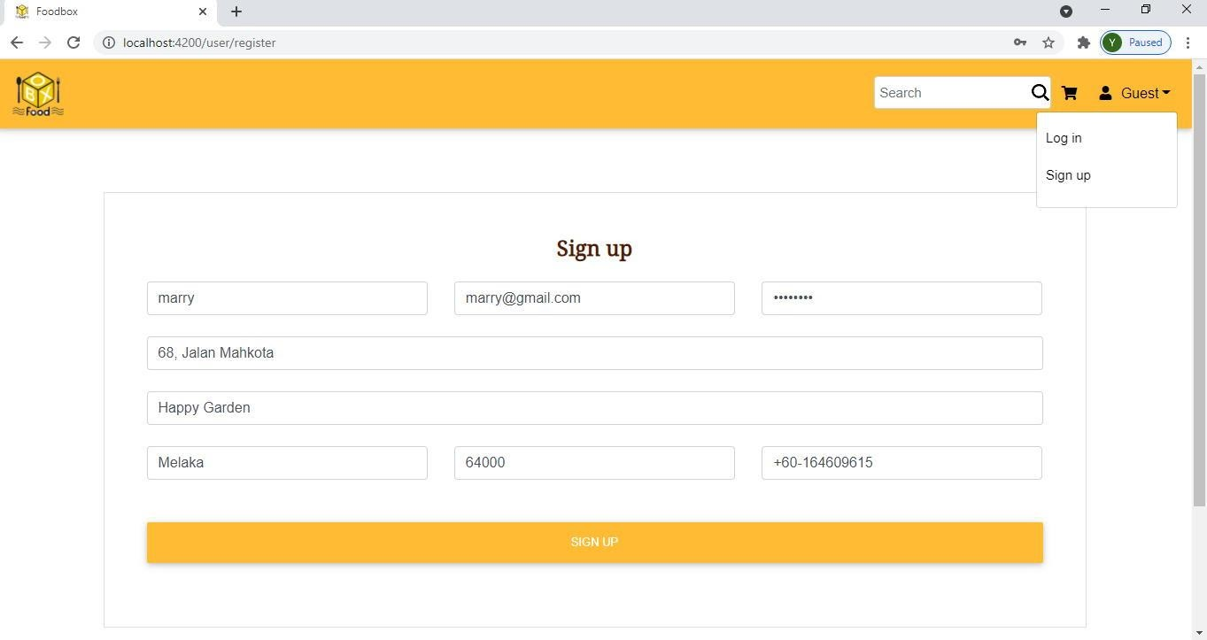

*Figure 30 User – Register*

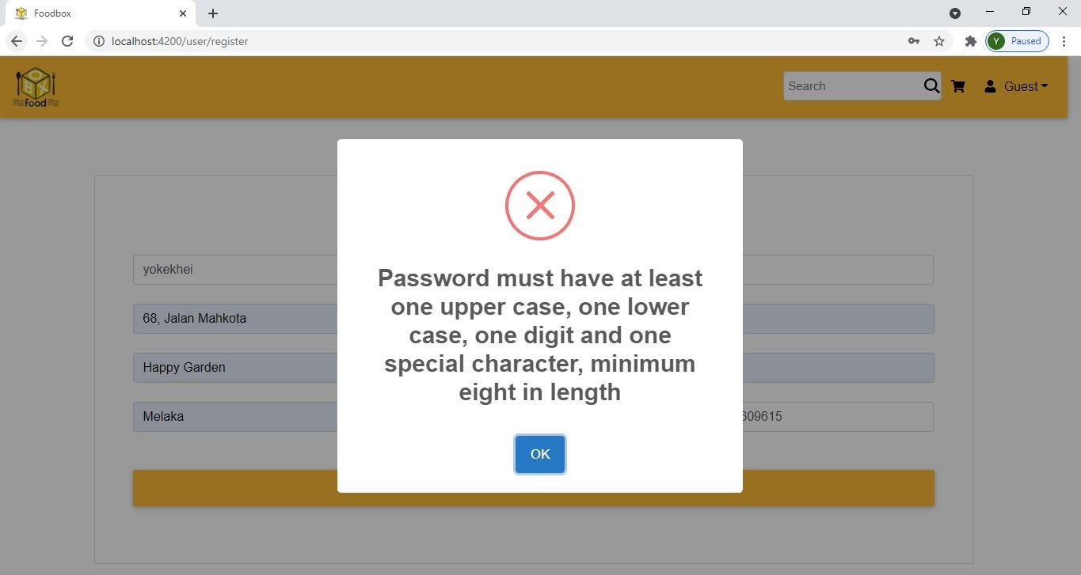

*Figure 31 User - Register Failure*

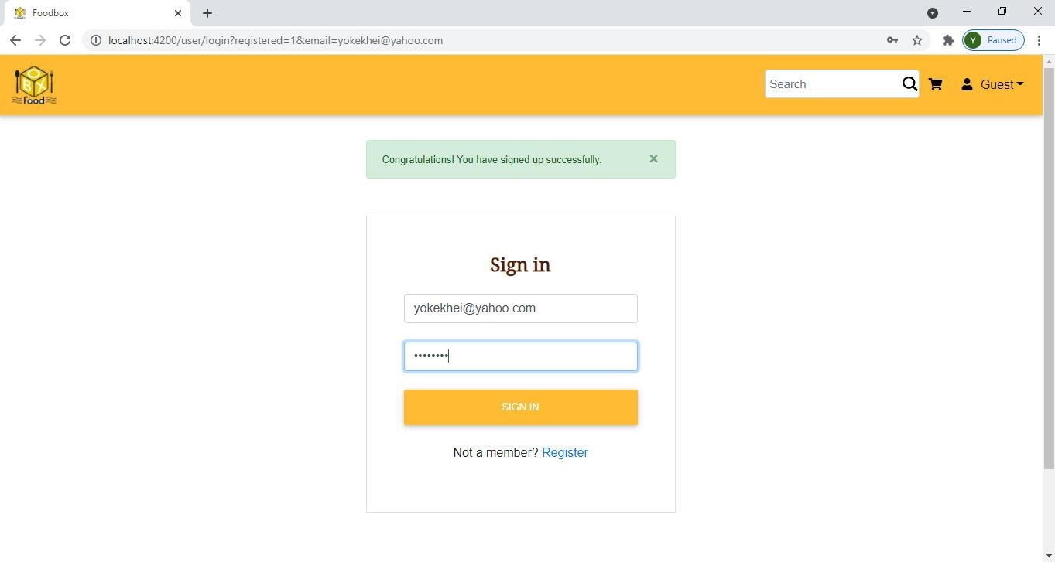

*Figure 32 User – Login*

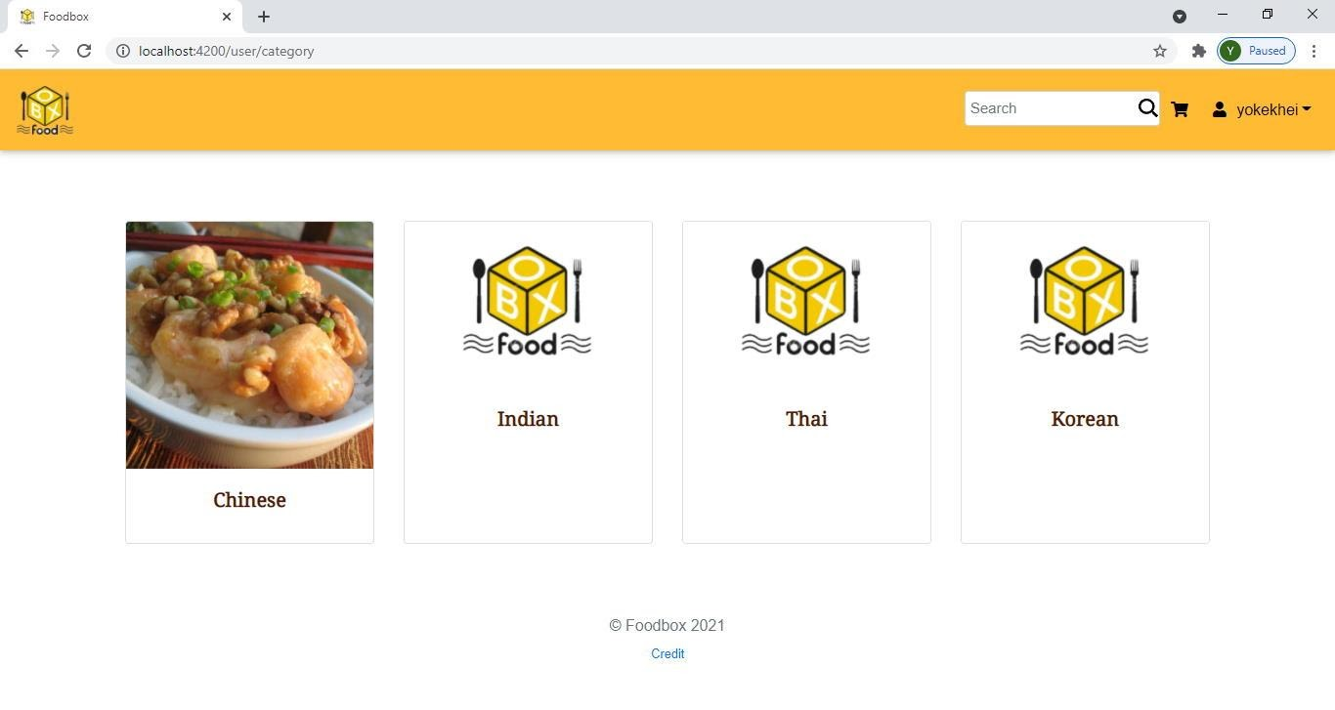

*Figure 33 User – Categories*

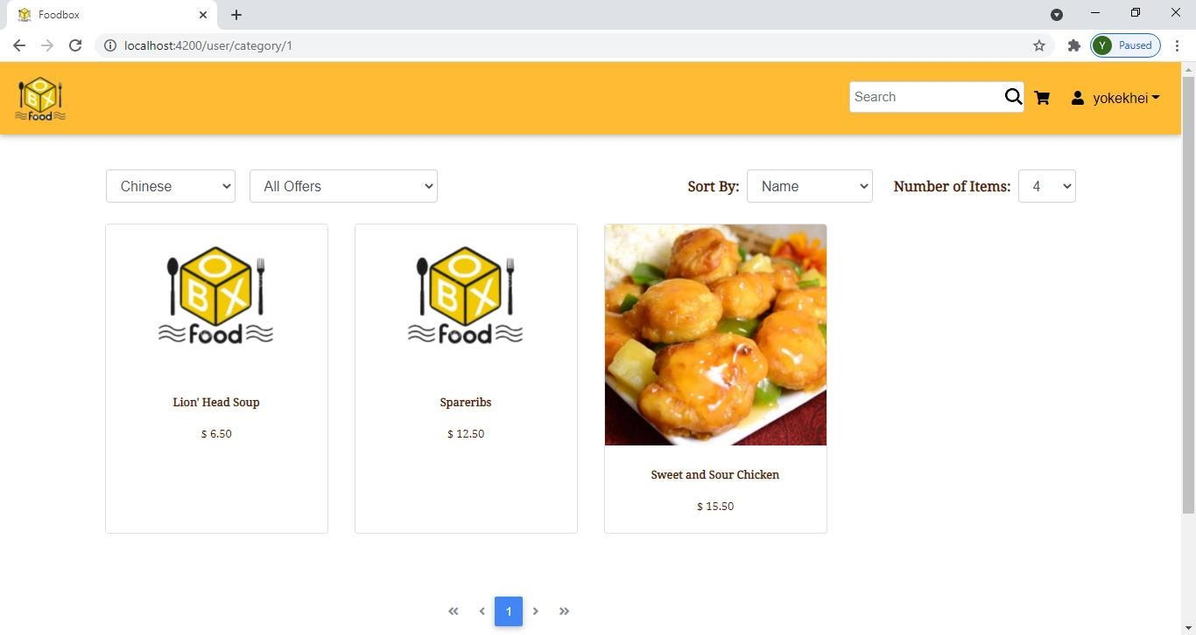

*Figure 34 User - Foods Filtered by Category*

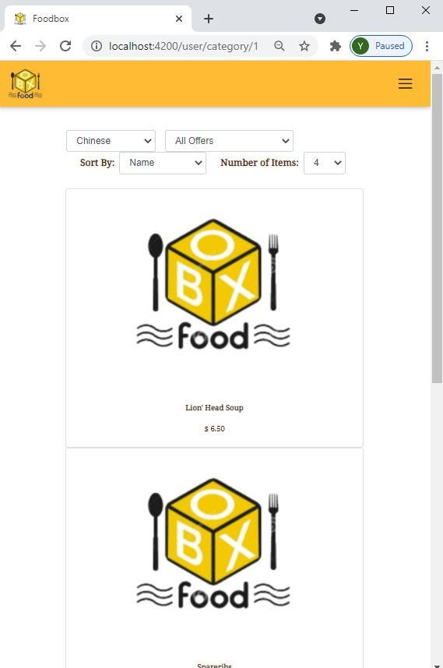

*Figure 35 User - Foods Filtered by Category in Responsive View*

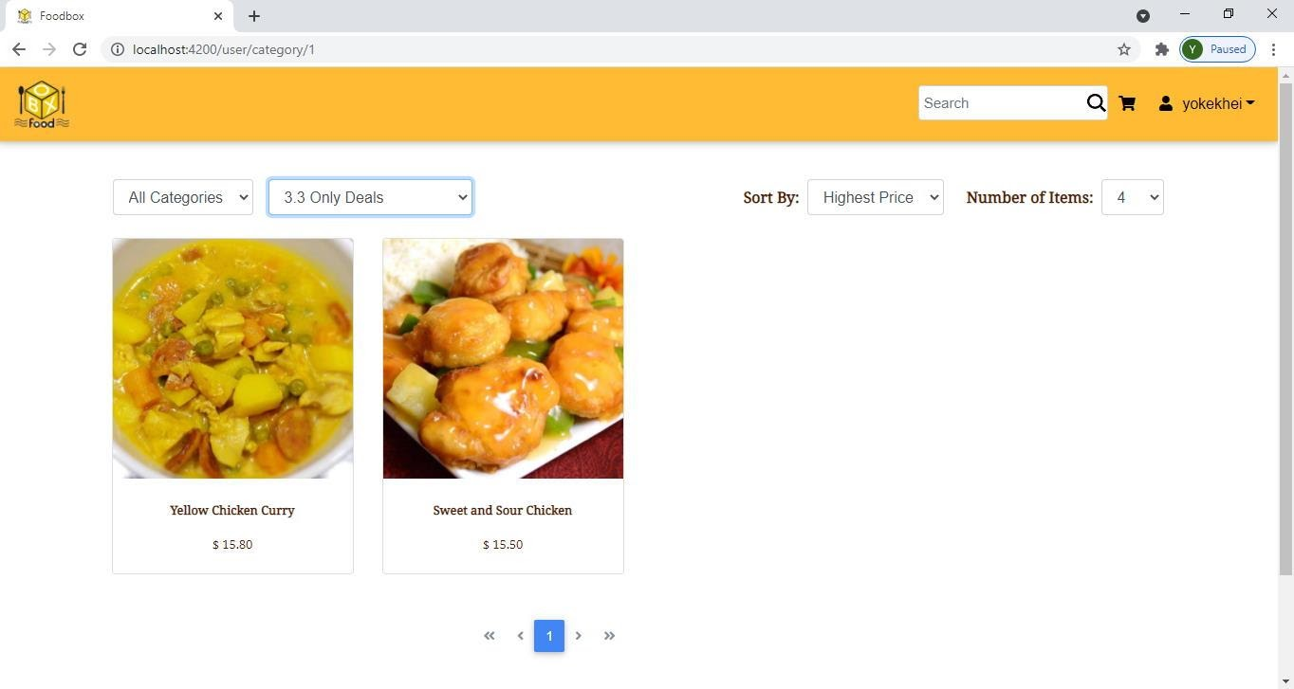

*Figure 36 User - Foods Filtered by Offer*

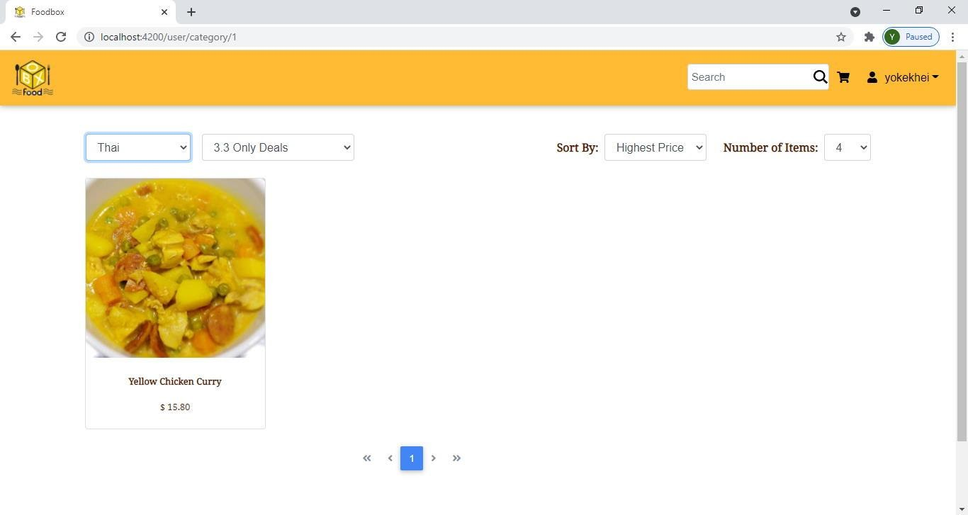

*Figure 37 User - Foods Filtered by Category & Offer*

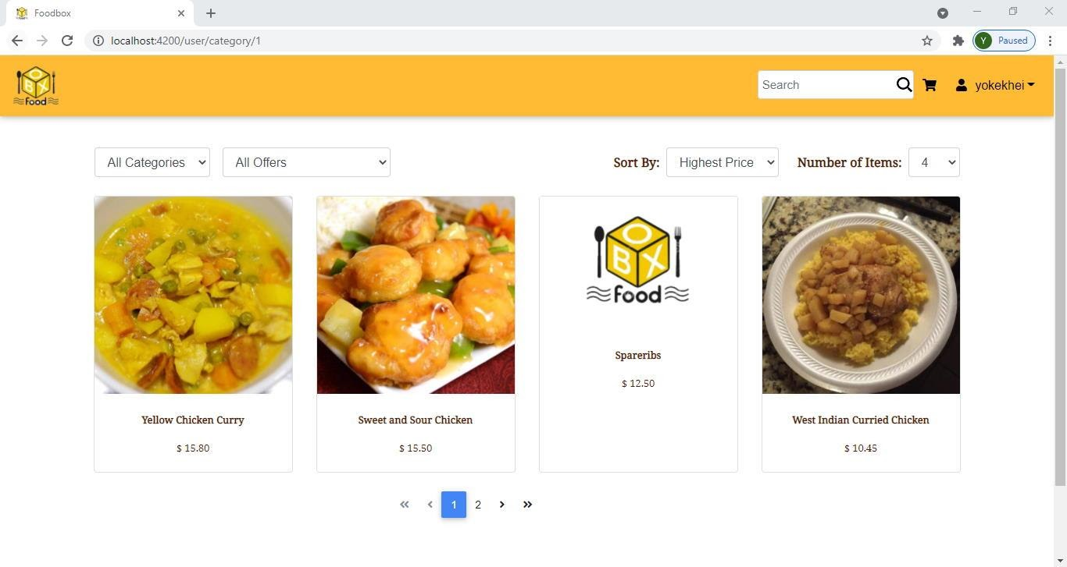

*Figure 38 User - Foods Sorted by Highest Price*

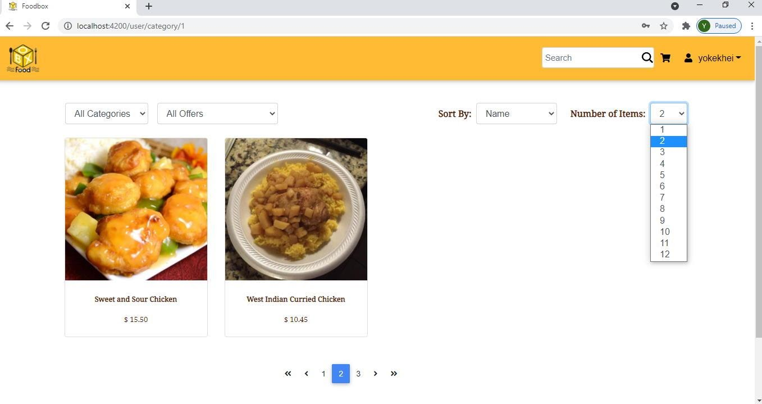

*Figure 39 User - Foods Displayed by Pagination*

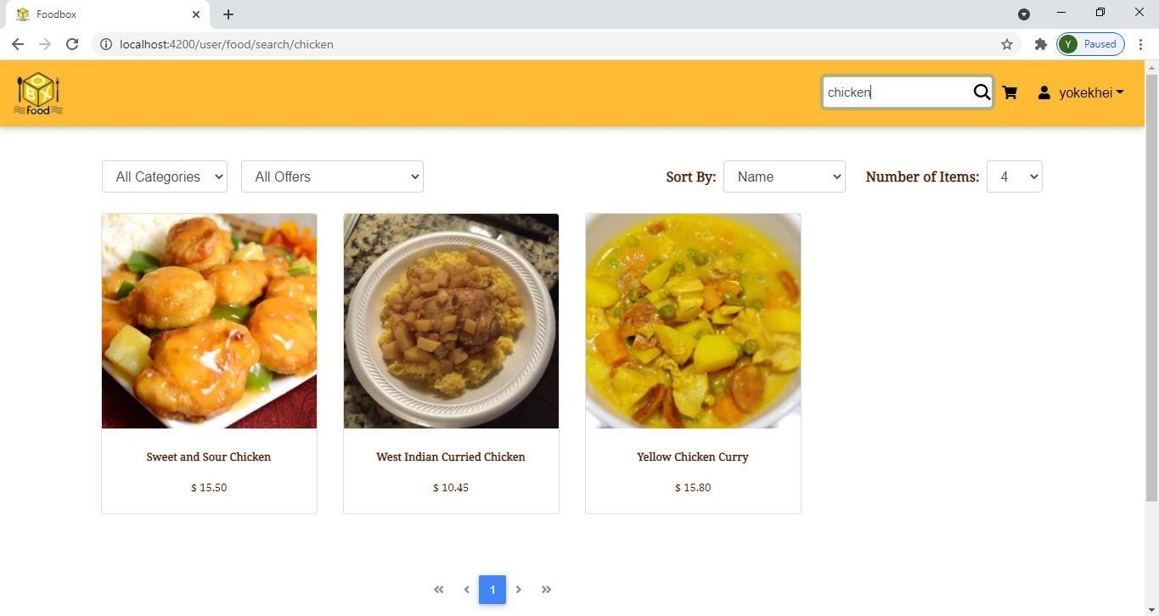

*Figure 40 User - Food Search*

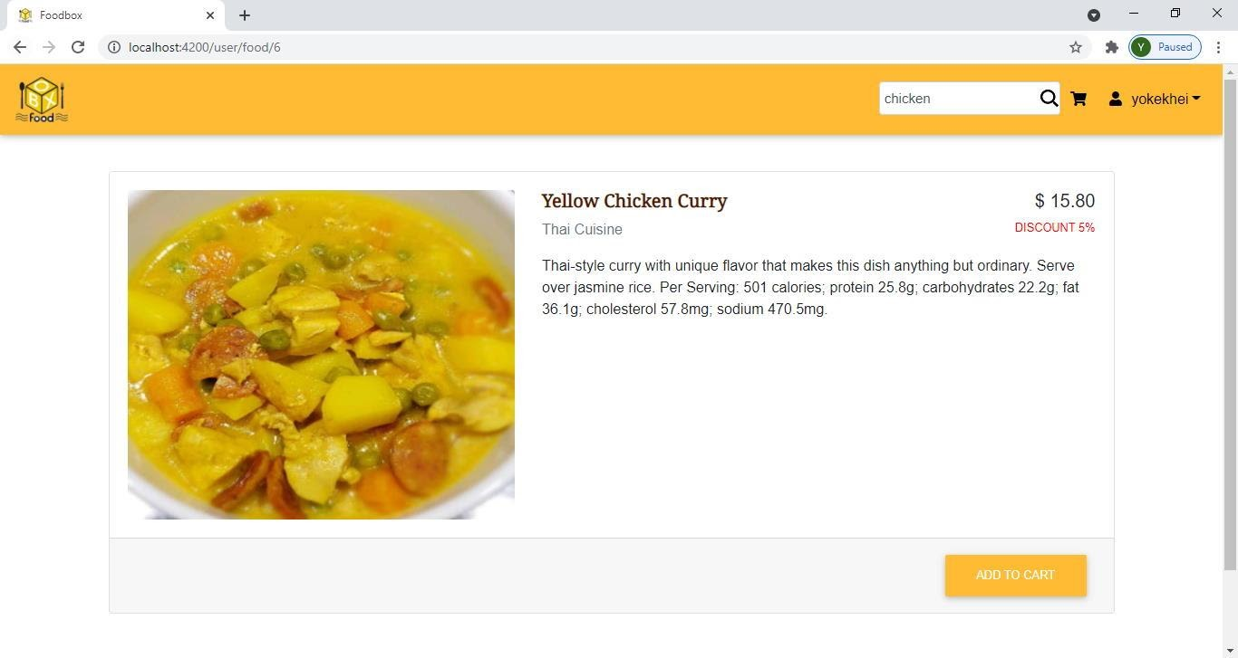

*Figure 41 User - Food Details*

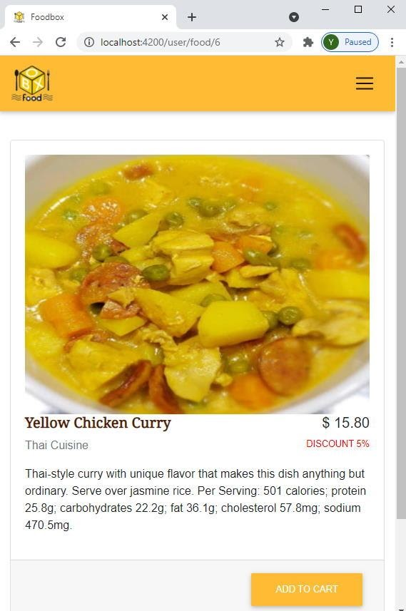

*Figure 42 User - Food Details in Responsive View*

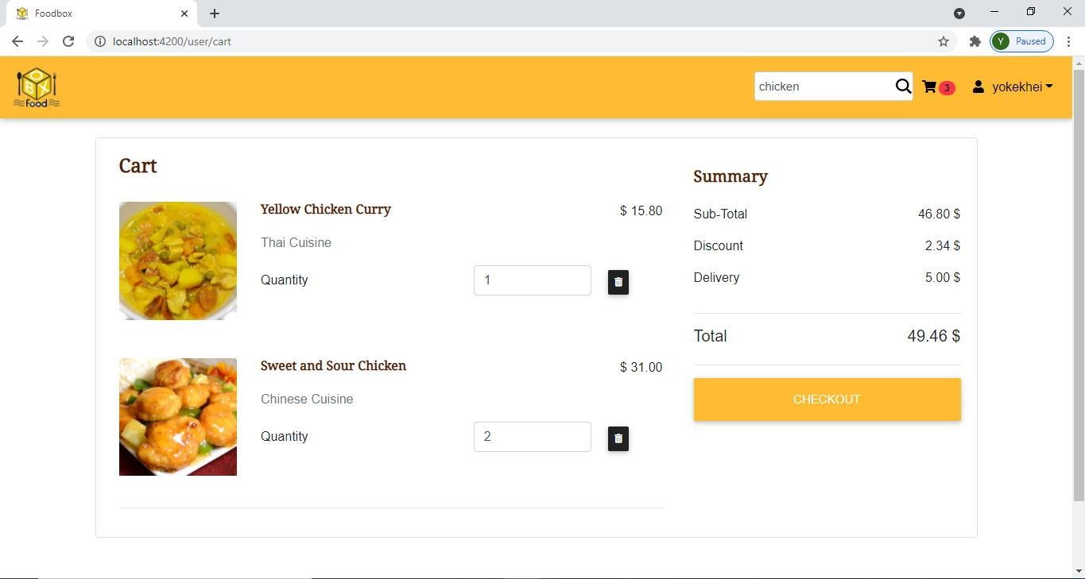

*Figure 43 User – Cart*

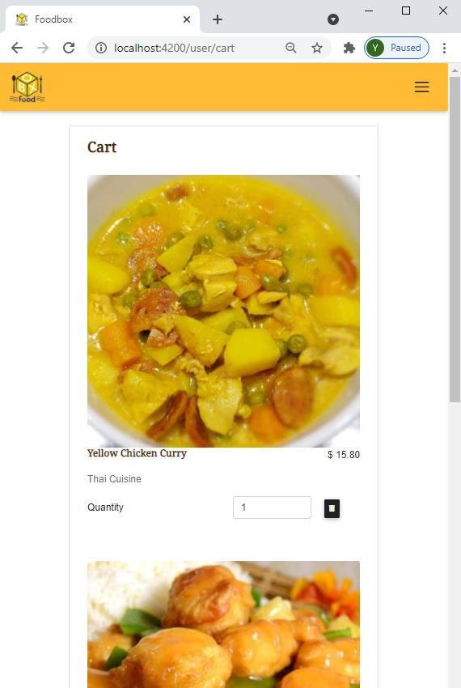

*Figure 44 User - Cart in Responsive View*

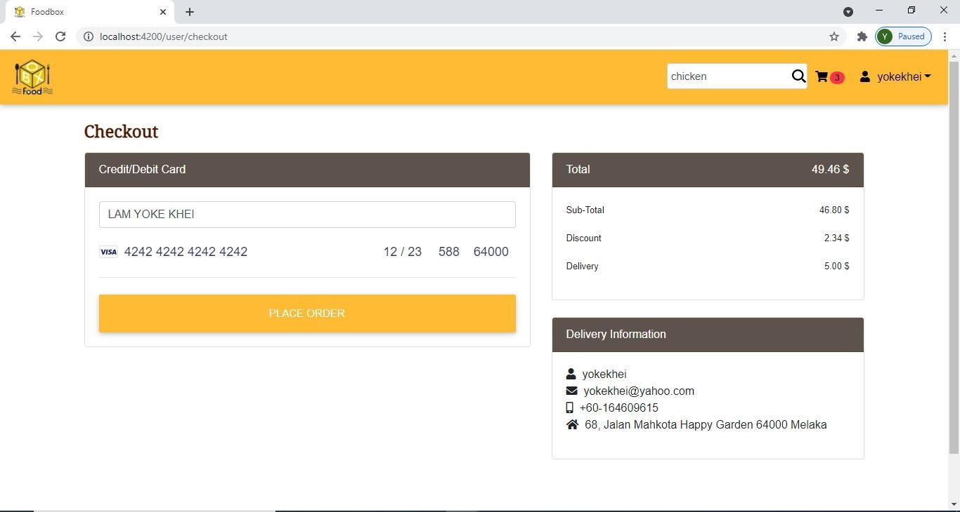

*Figure 45 User – Checkout*

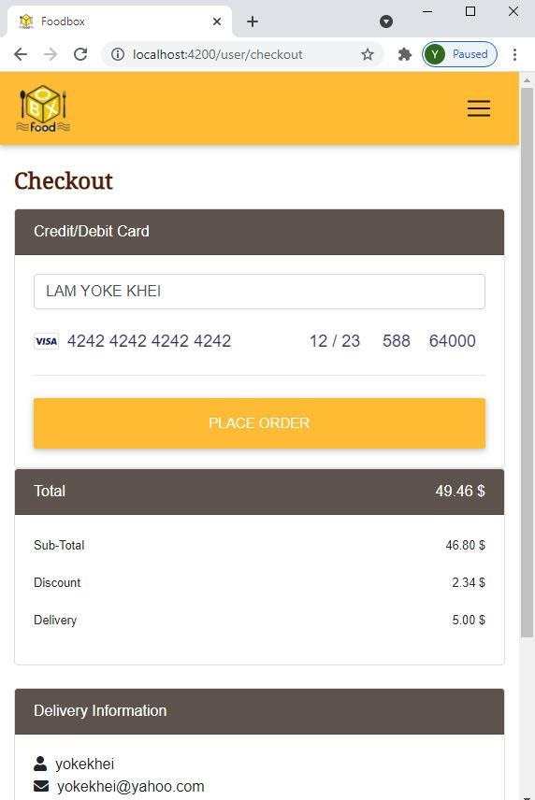

*Figure 46 User - Checkout in Responsive View*

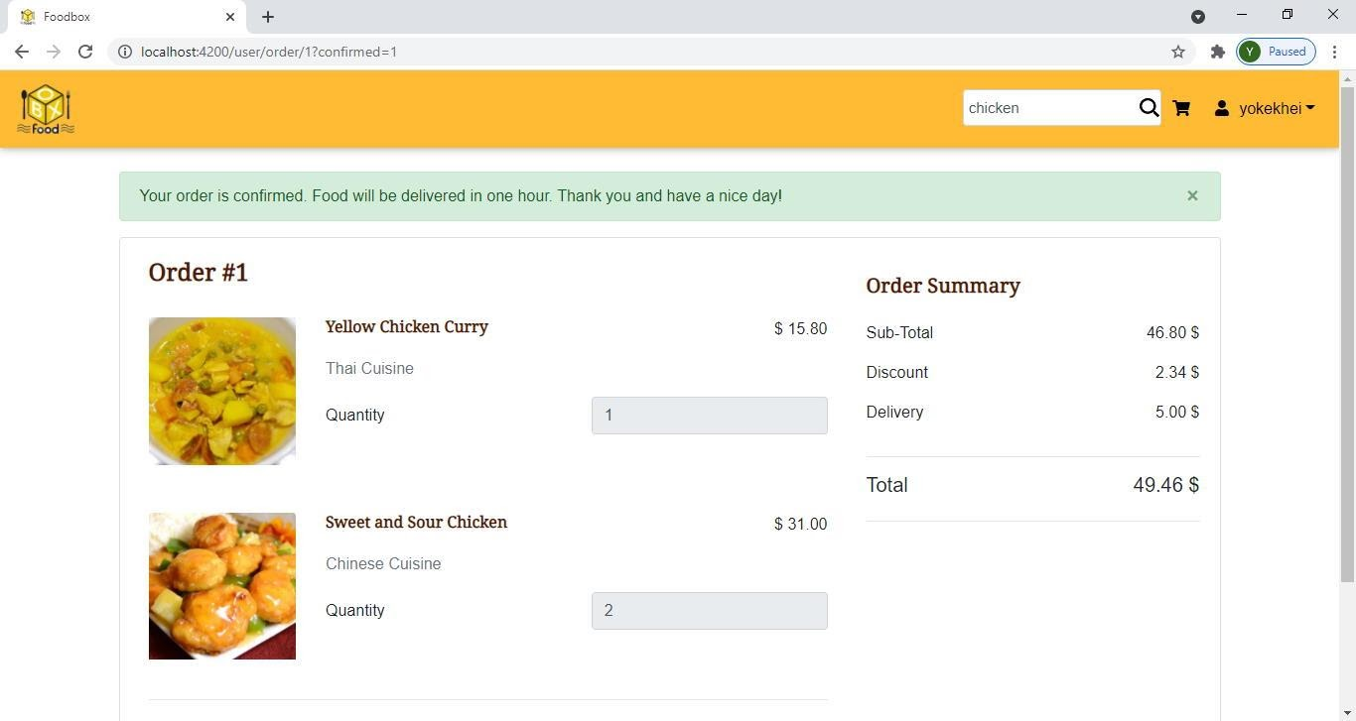

*Figure 47 User - Order Confirmation*

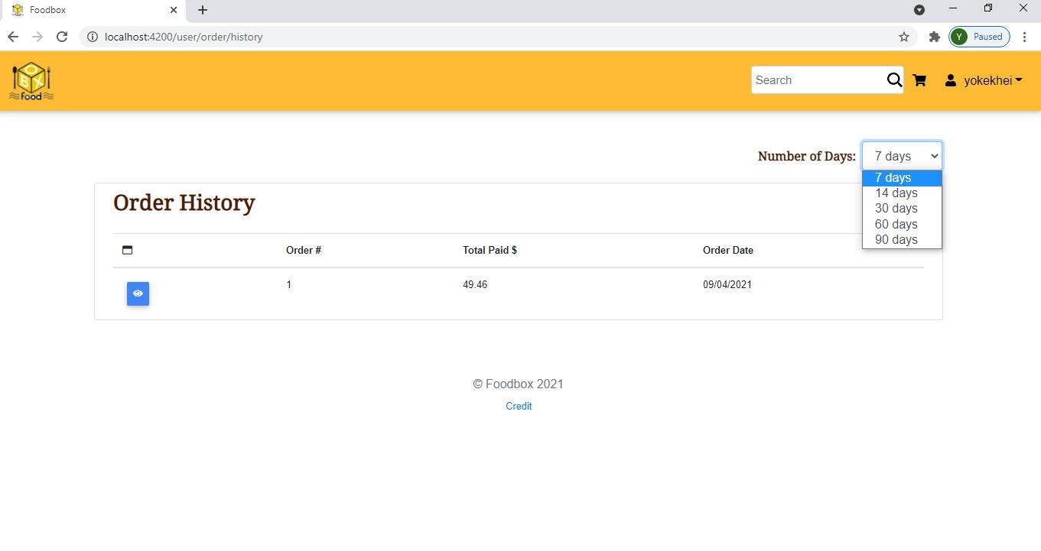

*Figure 48 User - Order History*

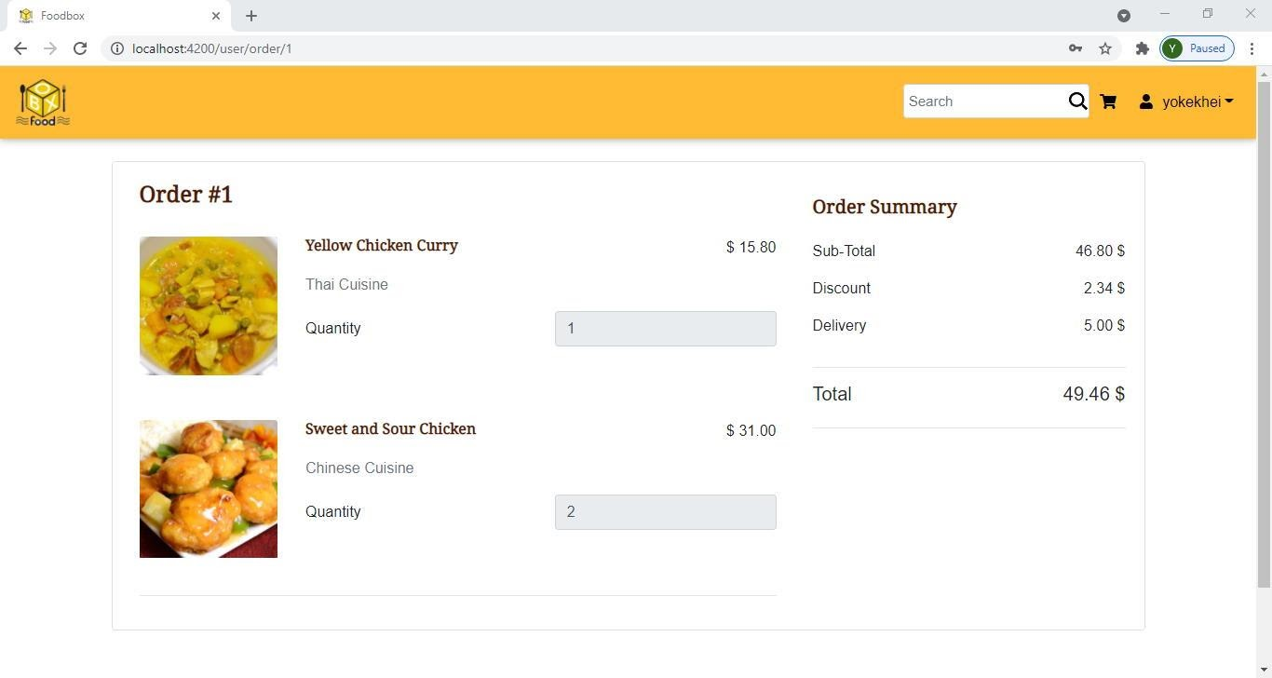

*Figure 49 User - Order Detail*

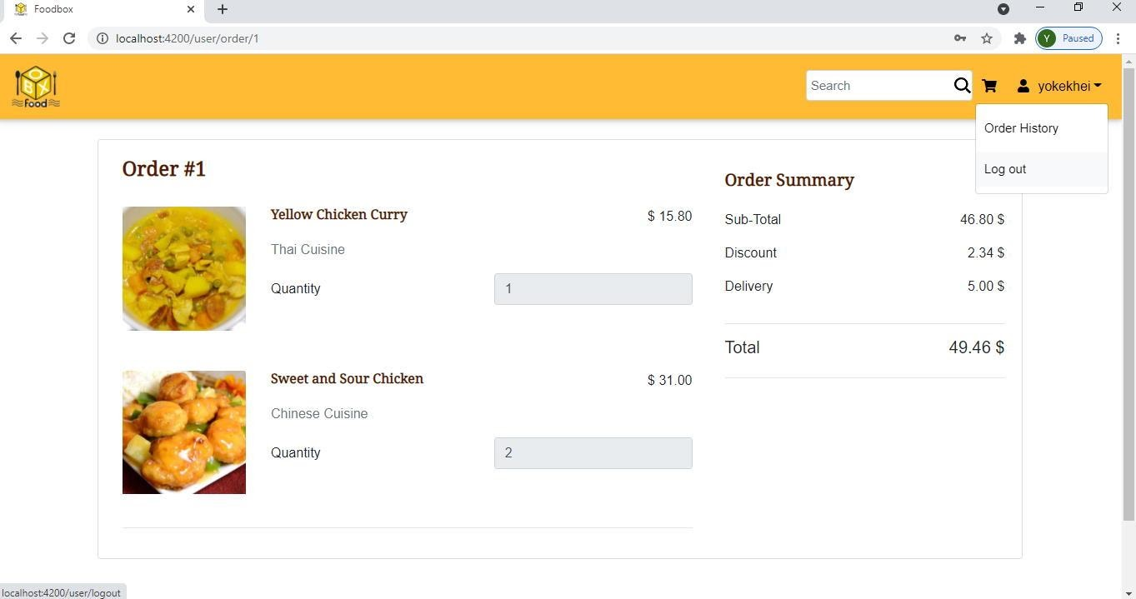

*Figure 50 User – Logout*

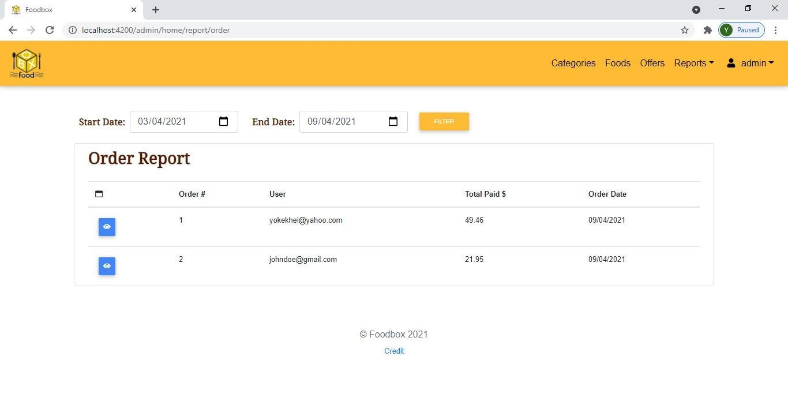

*Figure 51 Admin - Order Reports*

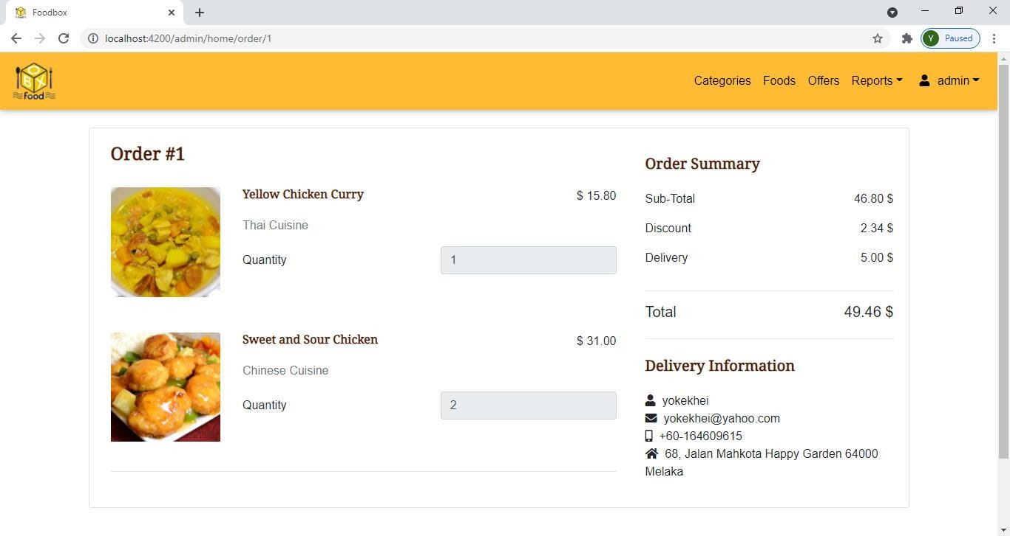

*Figure 52 Admin - Order Details*

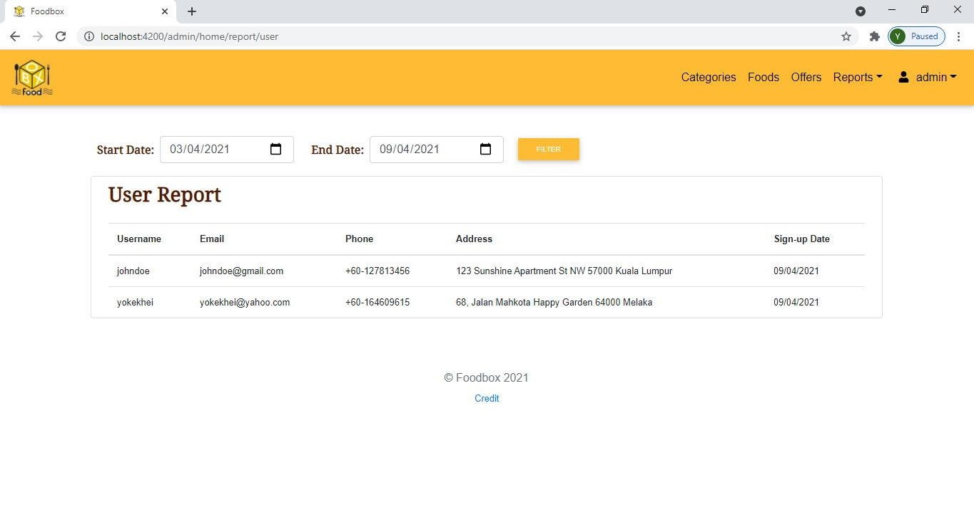

*Figure 53 Admin - User Report*

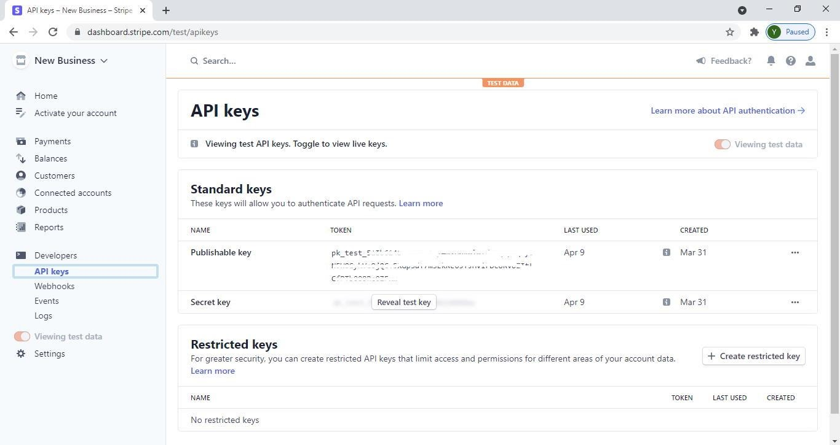

*Figure 54 Stripe Payment Gateway Test API Keys*

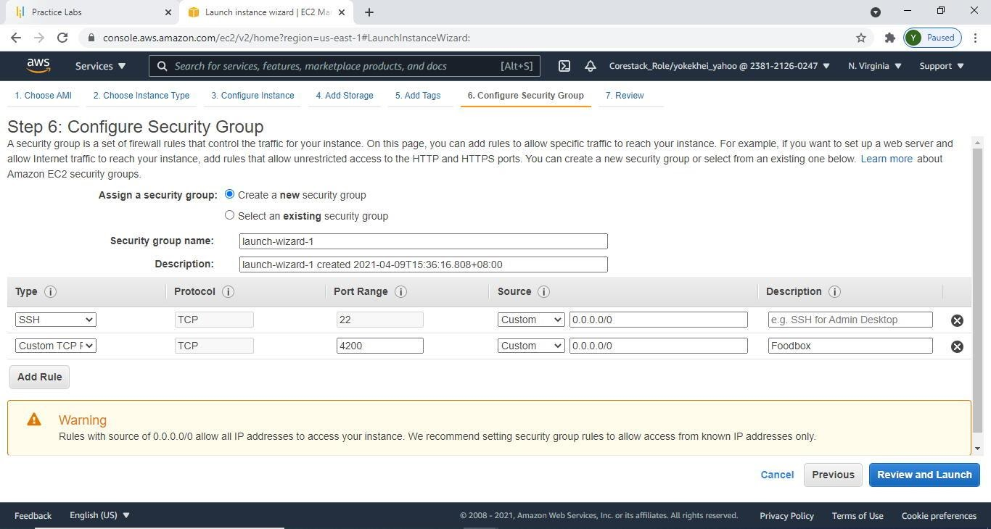

*Figure 55 DevOps - AWS EC2 Instance - Security Group Configuration*

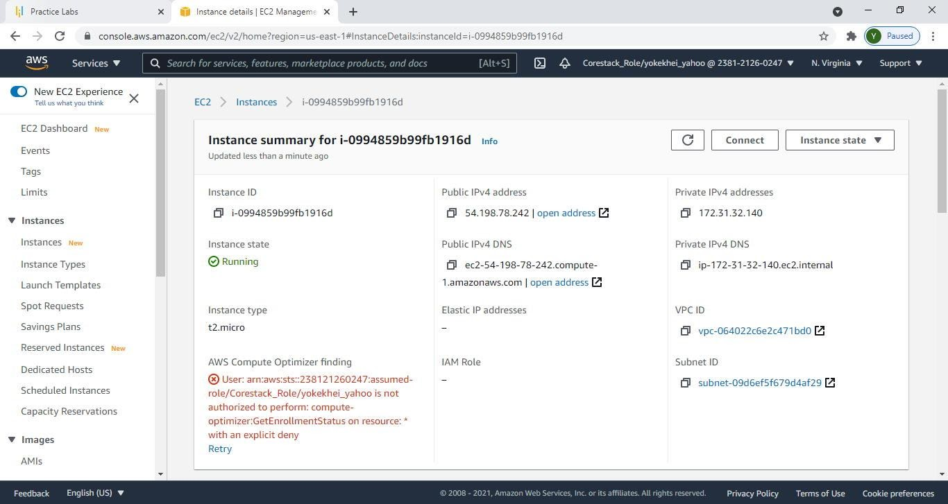

*Figure 56 DevOps - AWS EC2 Instance – Instance Created and Running*

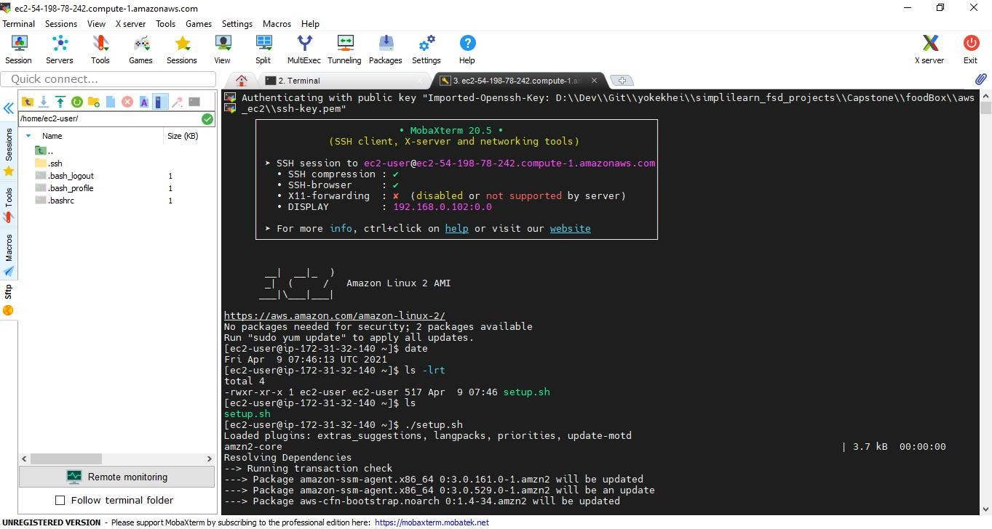

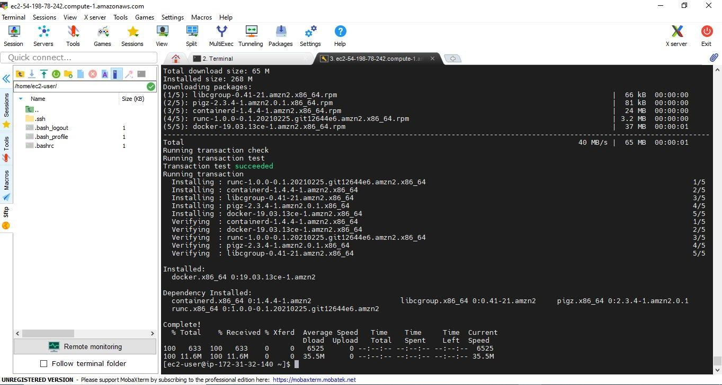

*Figure 57 DevOps - AWS EC2 Instance - Initial Setup*

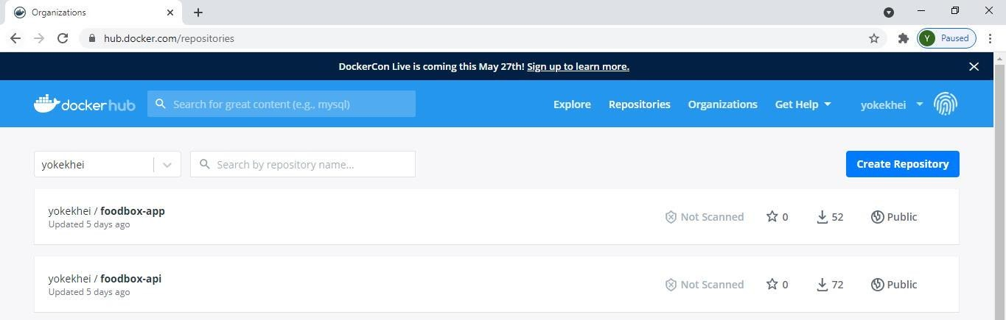

*Figure 58 DevOps - Docker Hub Repository*

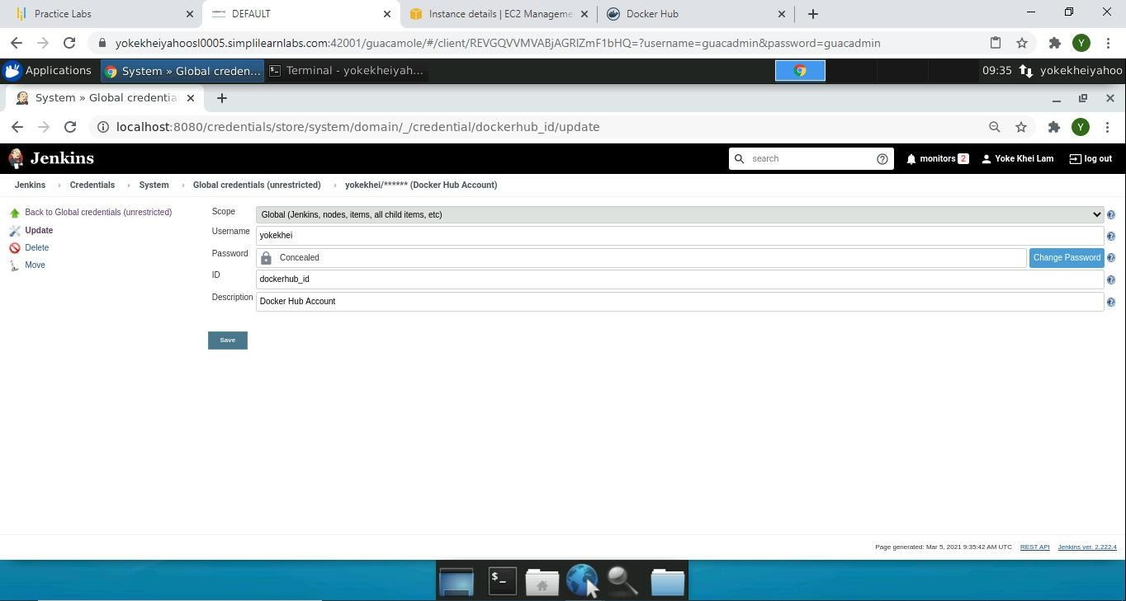

*Figure 59 DevOps - Jenkins - Docker Hub Configuration*

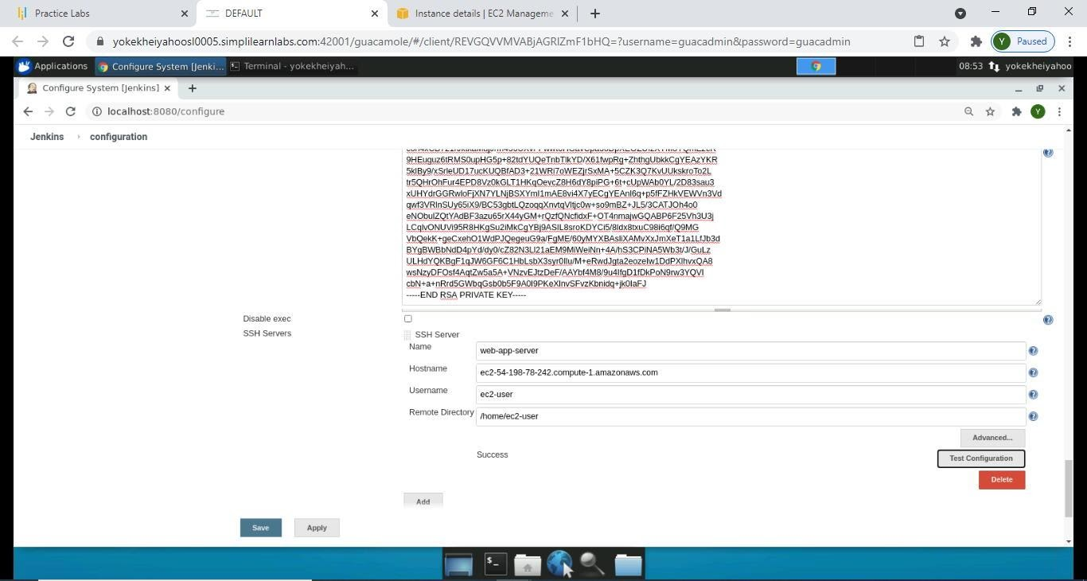

*Figure 60 DevOps - Jenkins - Publish over SSH to AWS EC2 Instance Configuration*

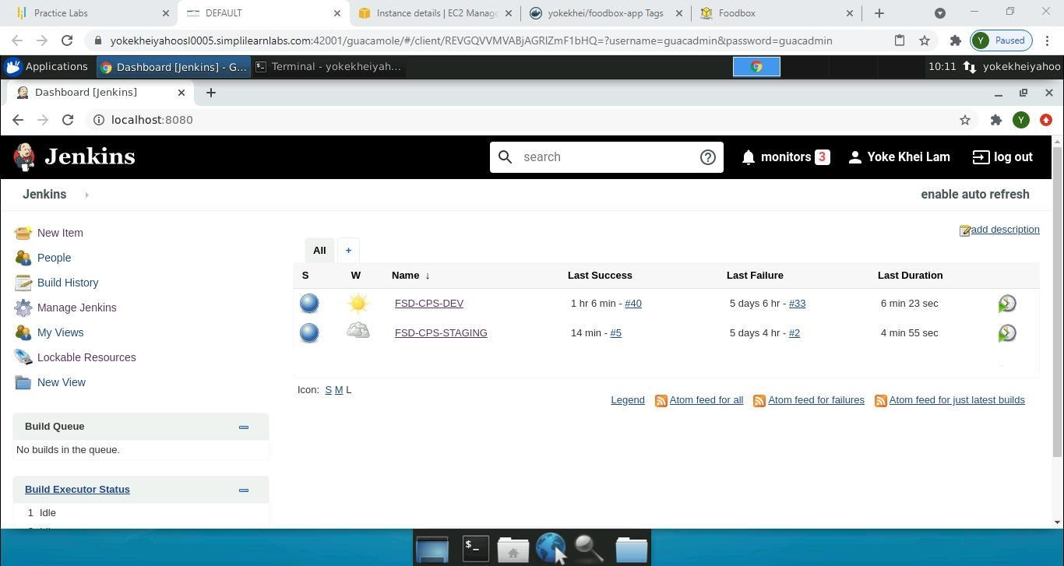

*Figure 61 DevOps - Jenkins – Jobs*

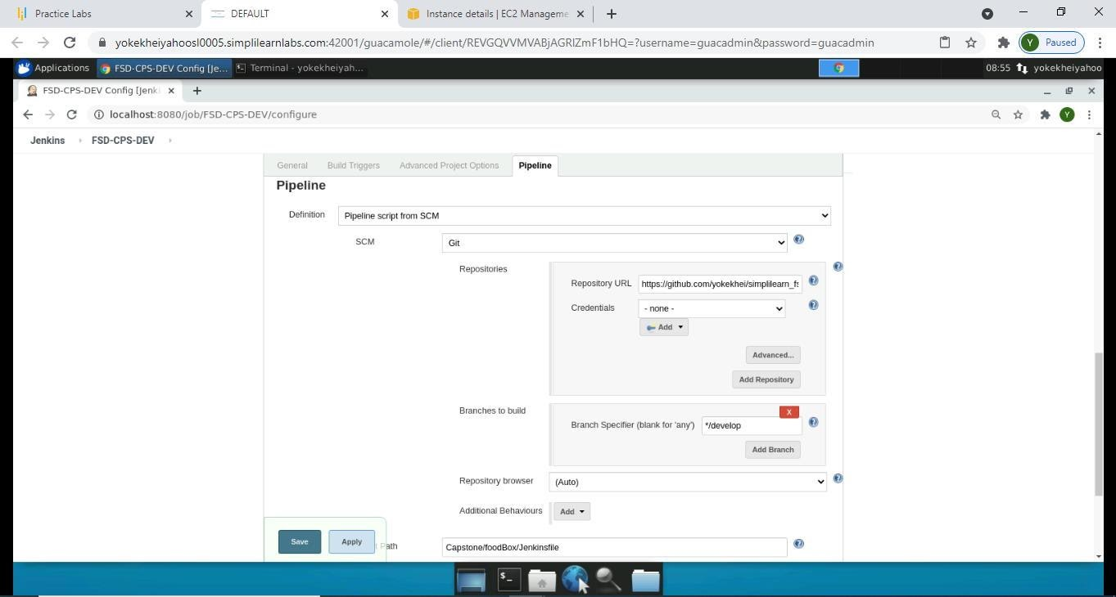

*Figure 62 DevOps - Jenkins - FSD-CPS-DEV Pipeline Configuration*

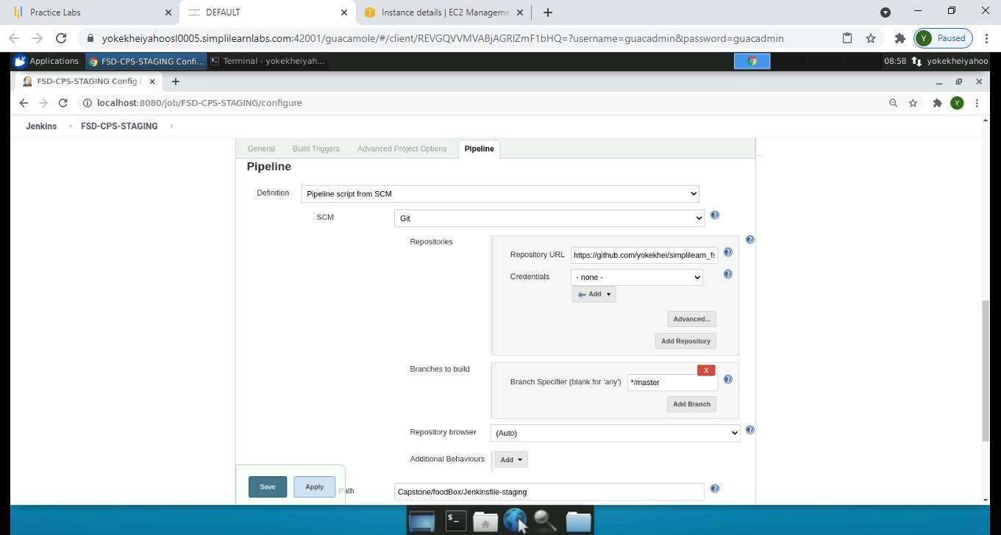

*Figure 63 DevOps - Jenkins - FSD-CPS-STAGING Pipeline Configuration*

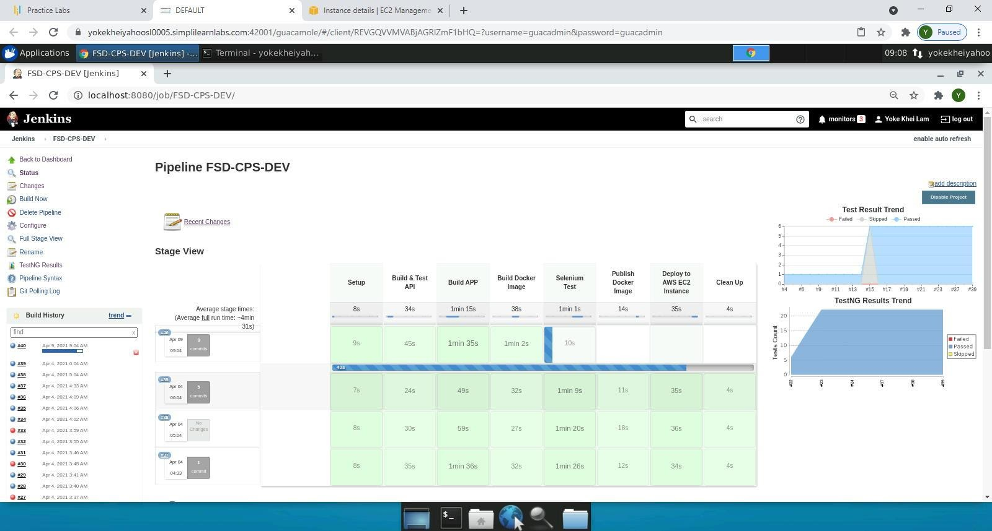

*Figure 64 DevOps - Jenkins - FSD-CPS-DEV Job Run (Build#40)*

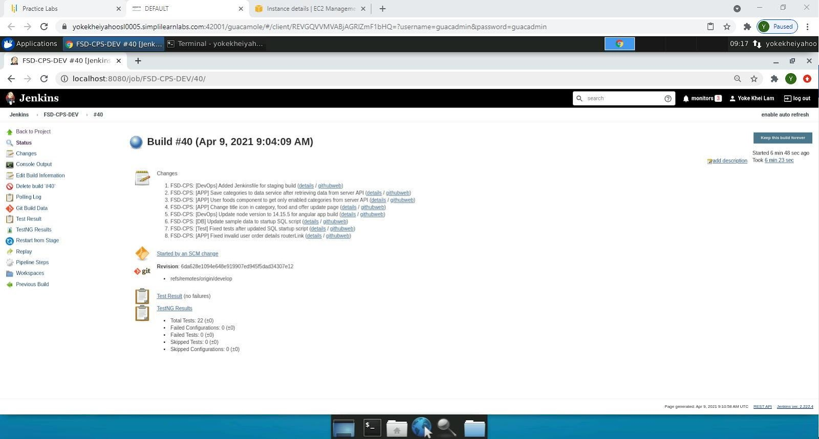

*Figure 65 DevOps - Jenkins - Build Summary*

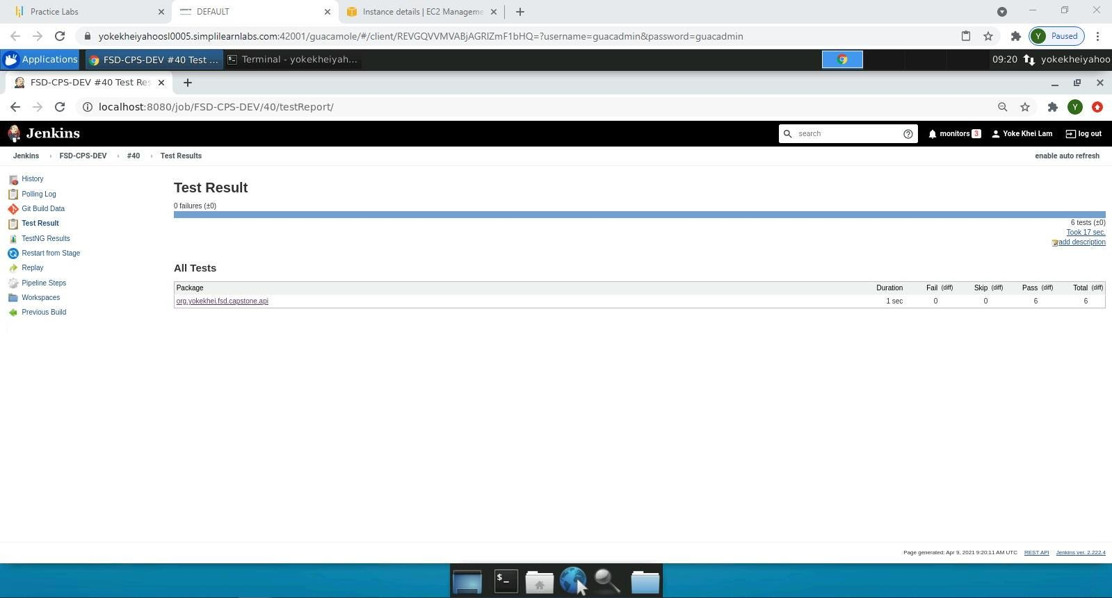

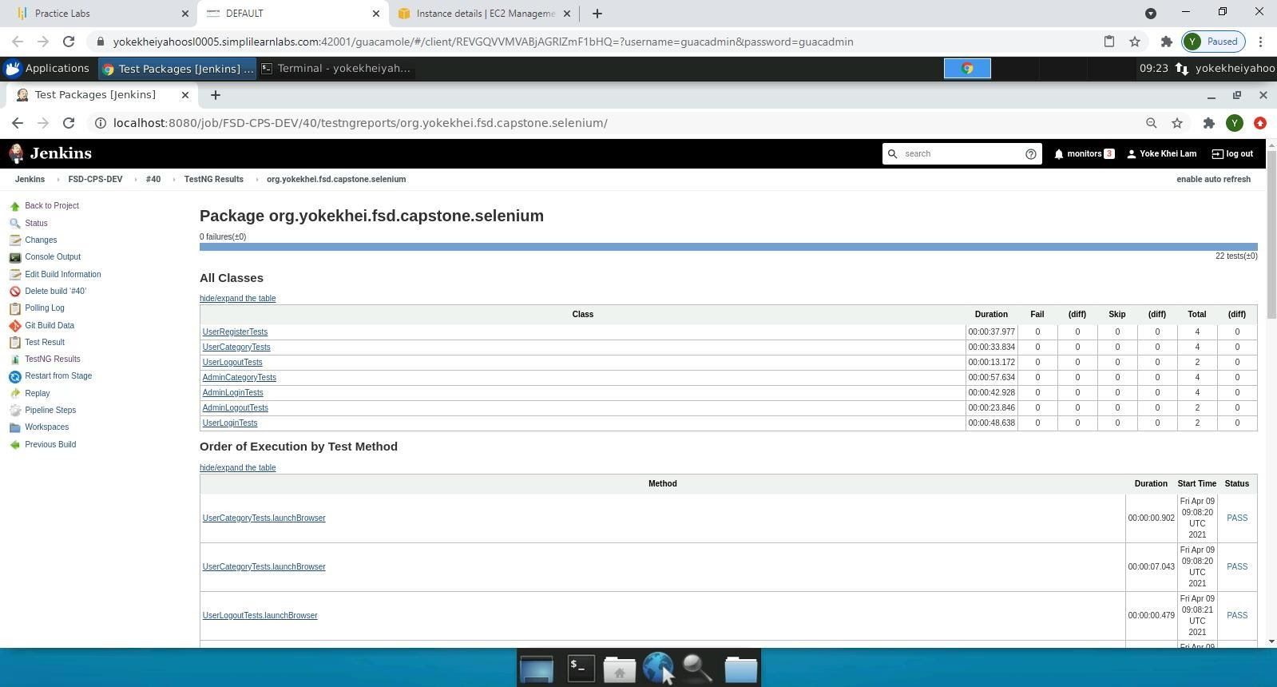

*Figure 66 DevOps - Jenkins - Test Report*

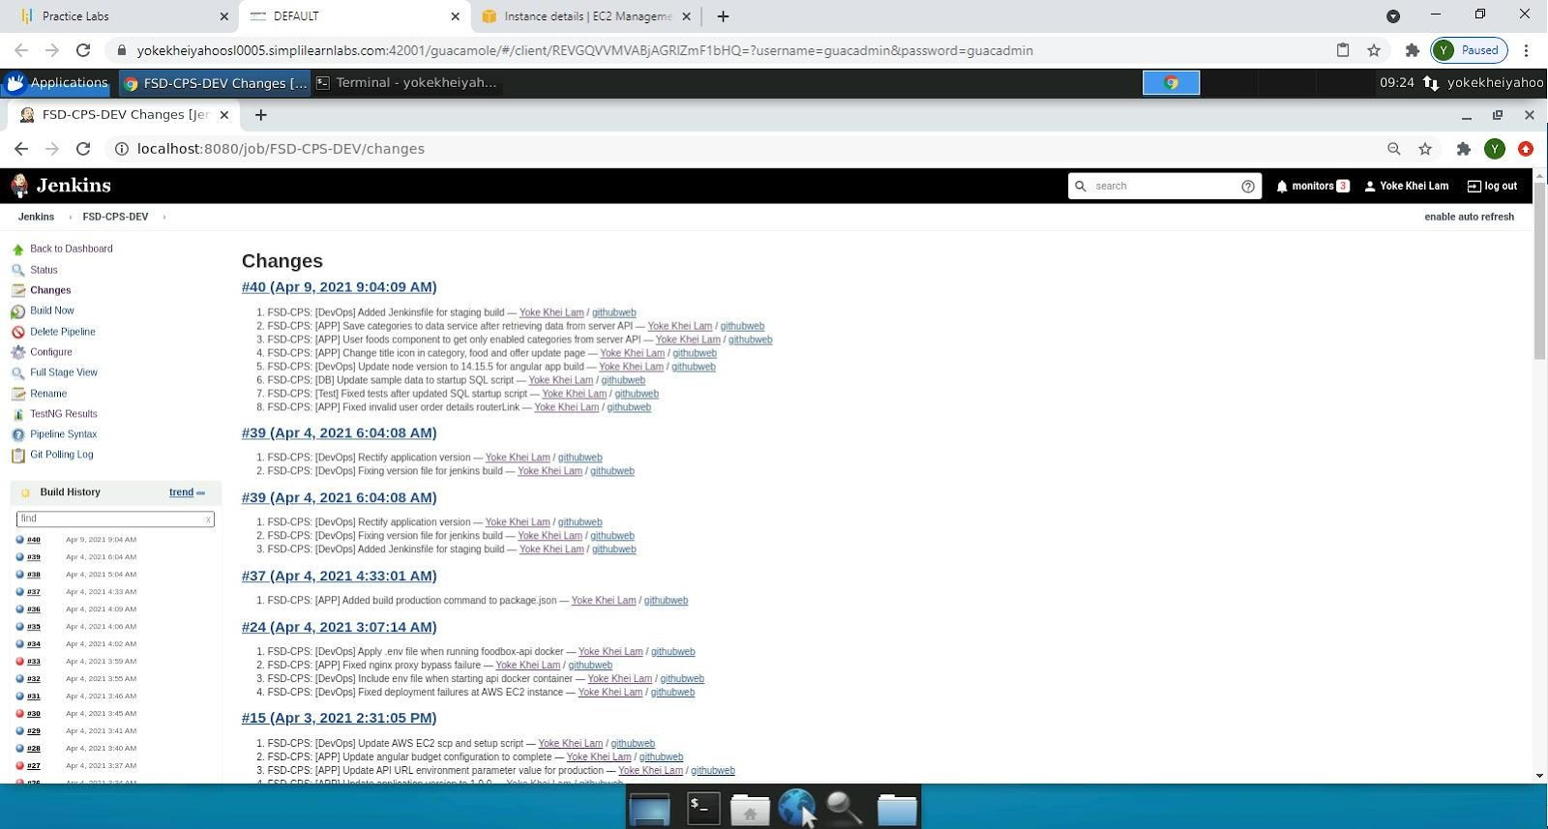

*Figure 67 DevOps - Jenkins - Recent Commit Changes*

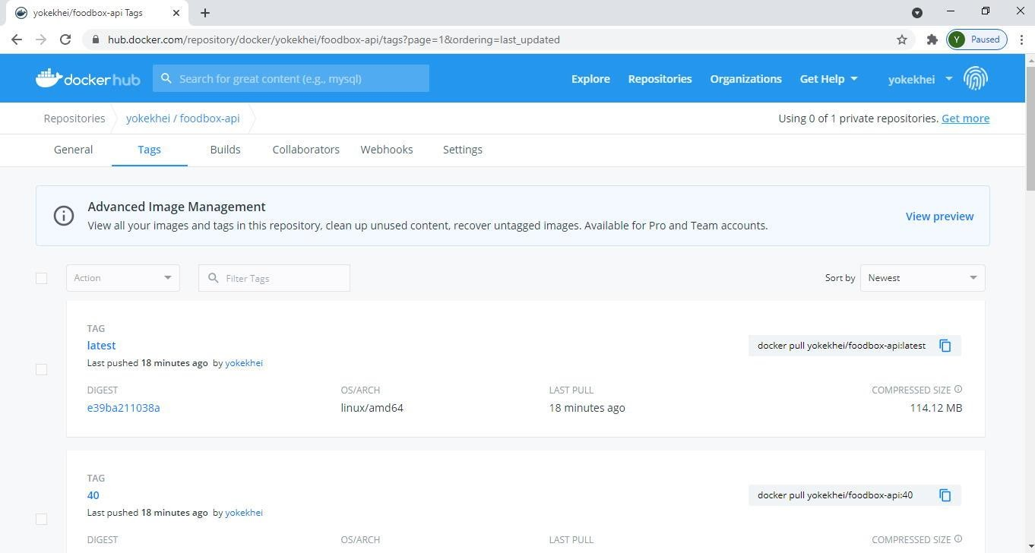

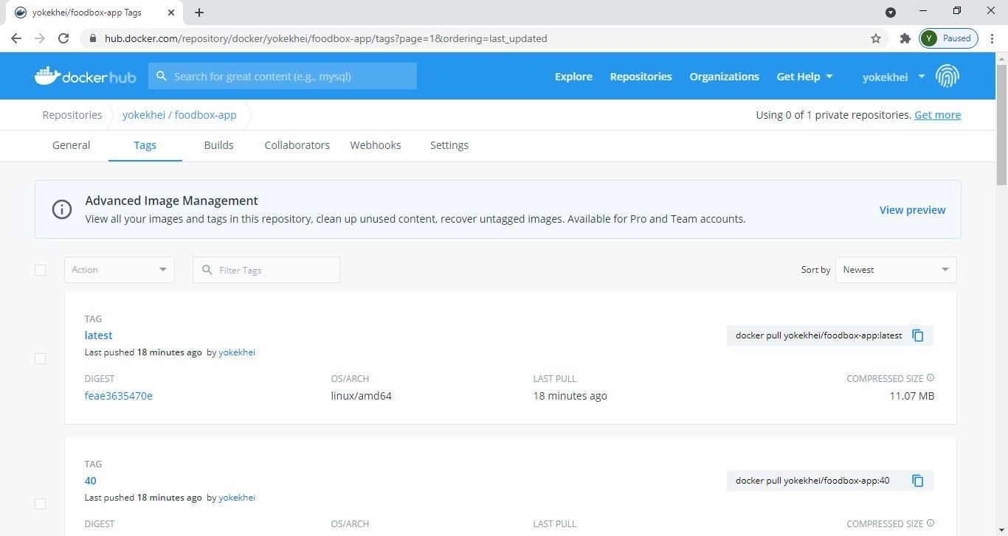

*Figure 68 DevOps - Published Docker Images*

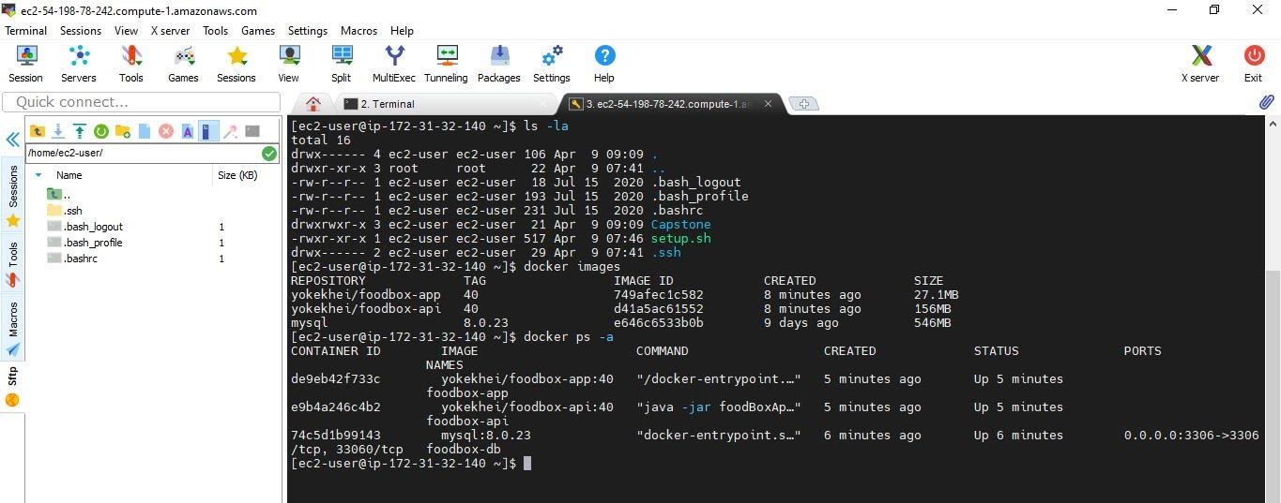

*Figure 69 DevOps - AWS EC2 Instance - Docker Images Deployed and Running Docker Containers*

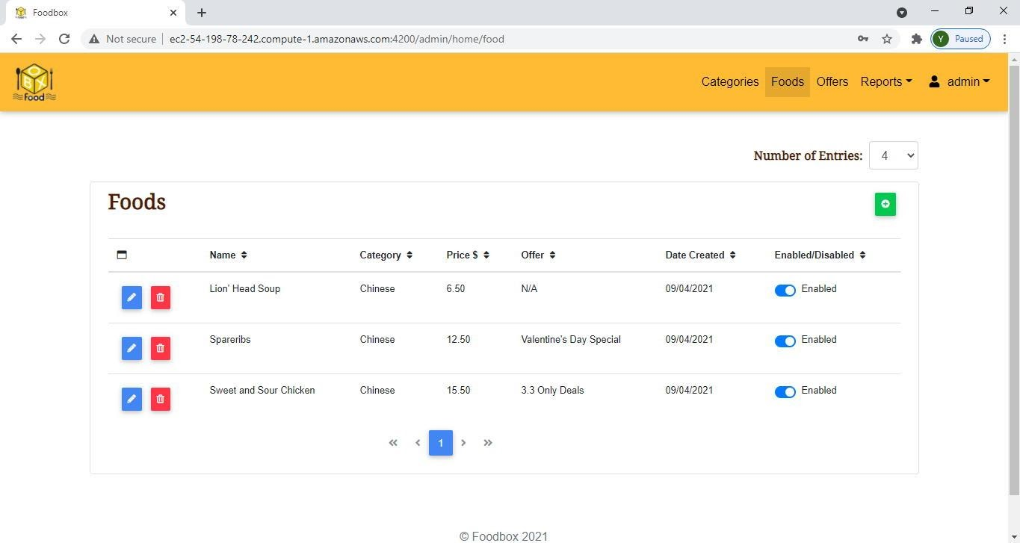

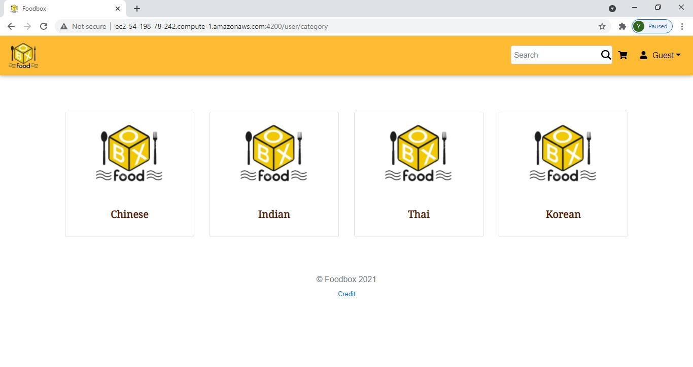

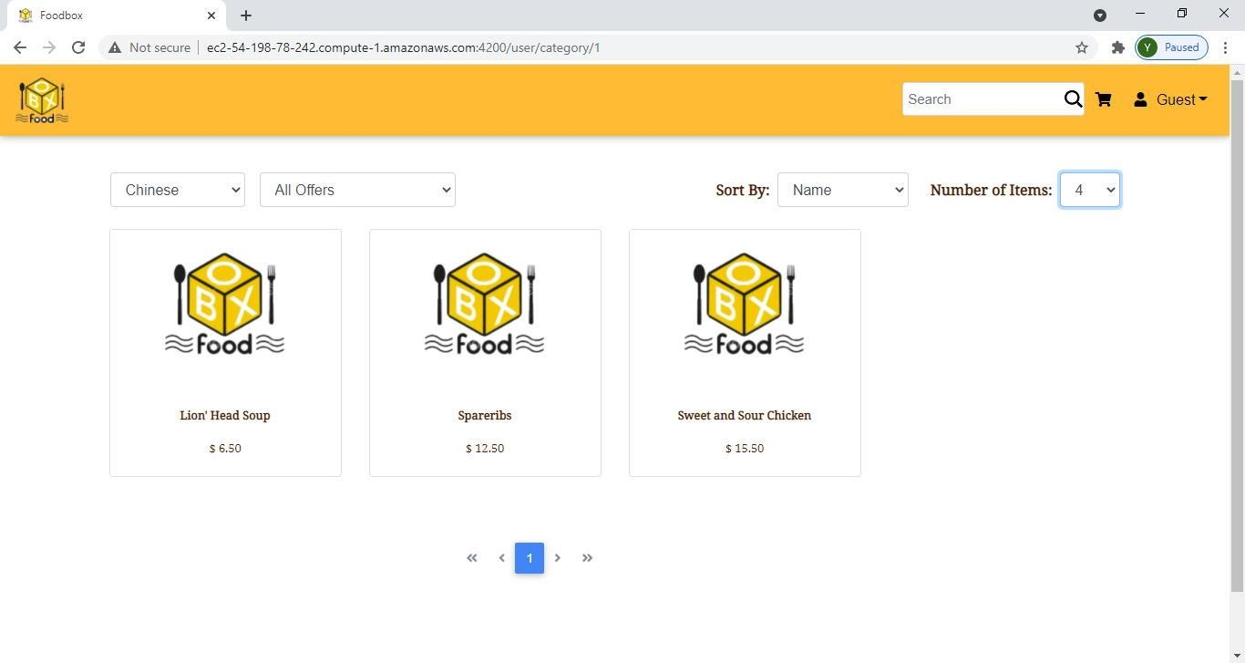

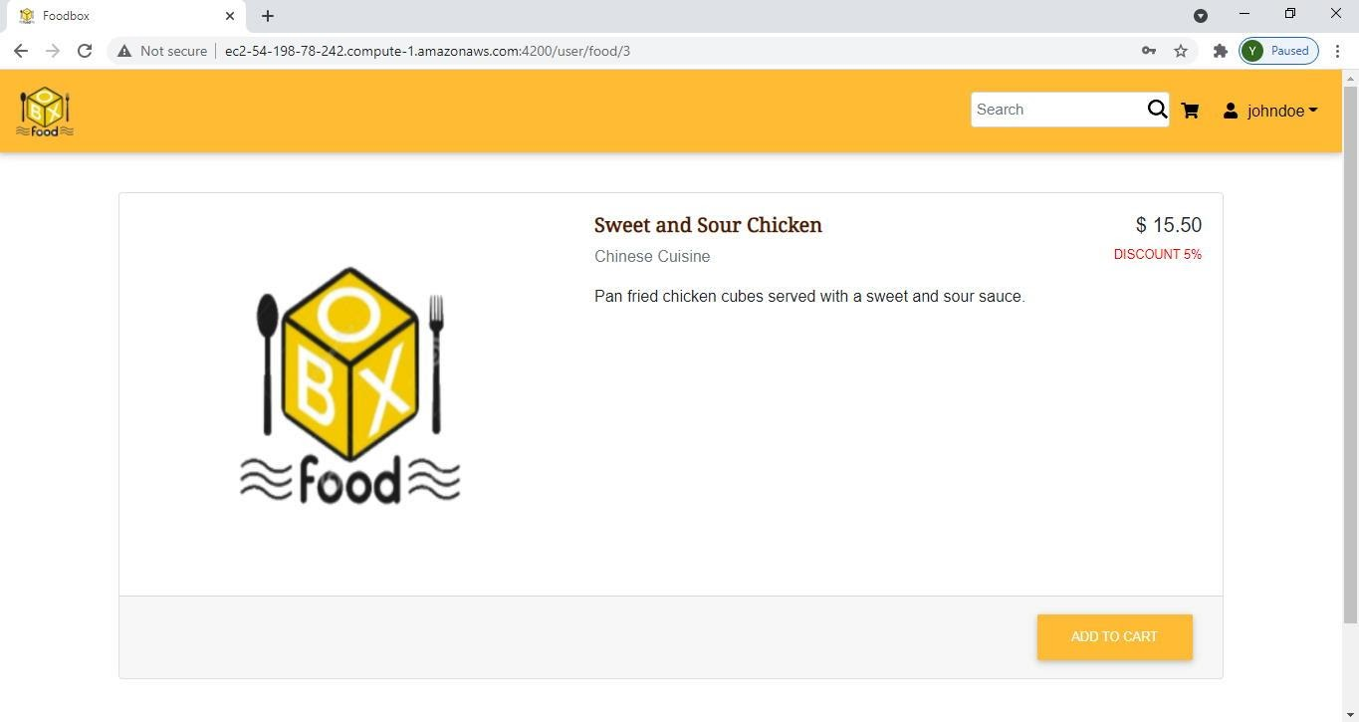

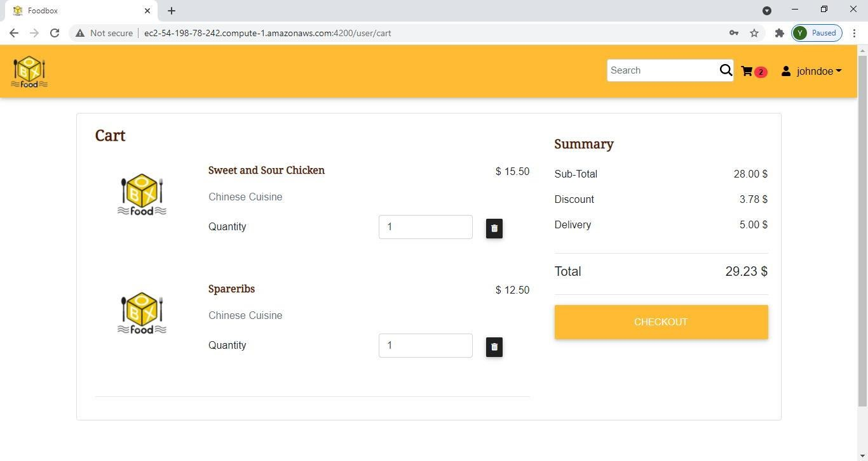

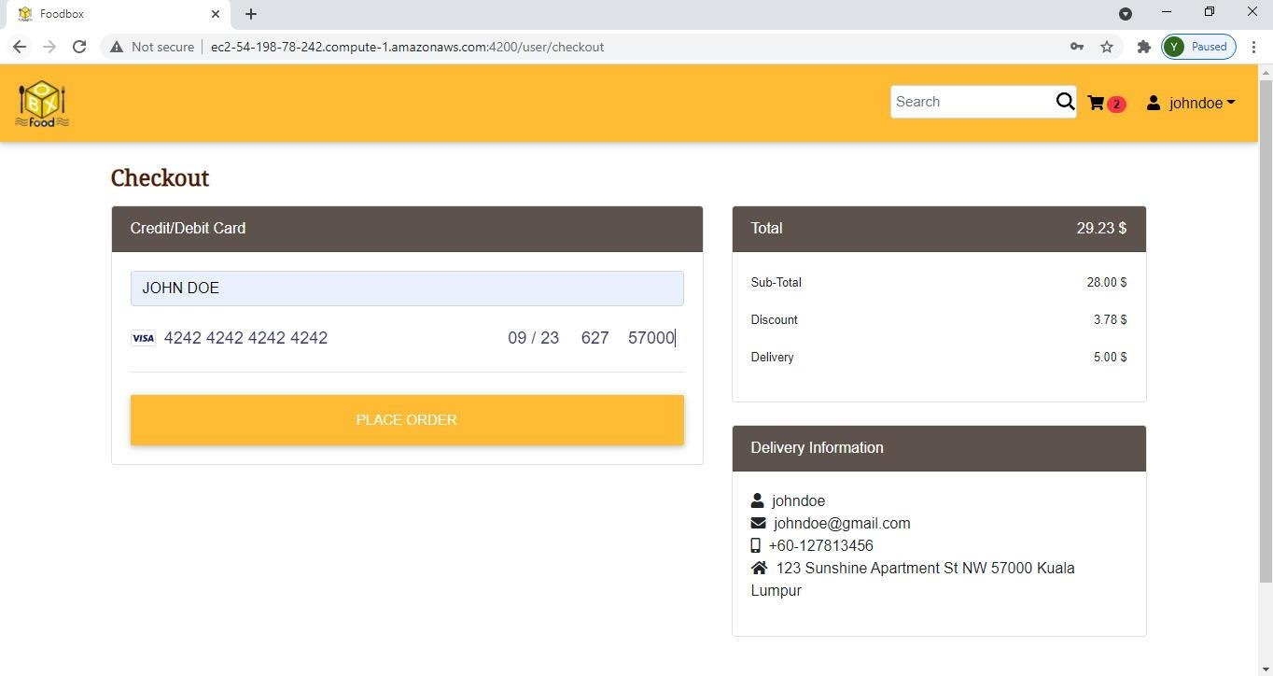

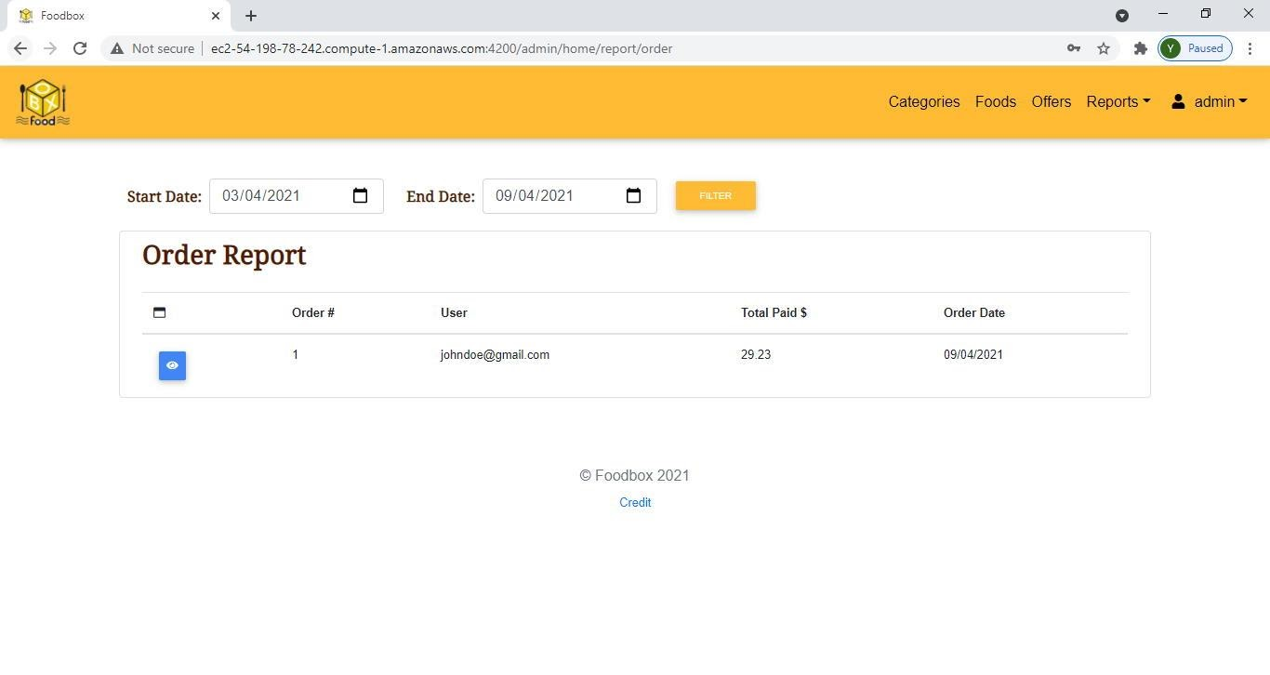

*Figure 70 DevOps - AWS EC2 Instance - Foodbox Application Deployed and Run*

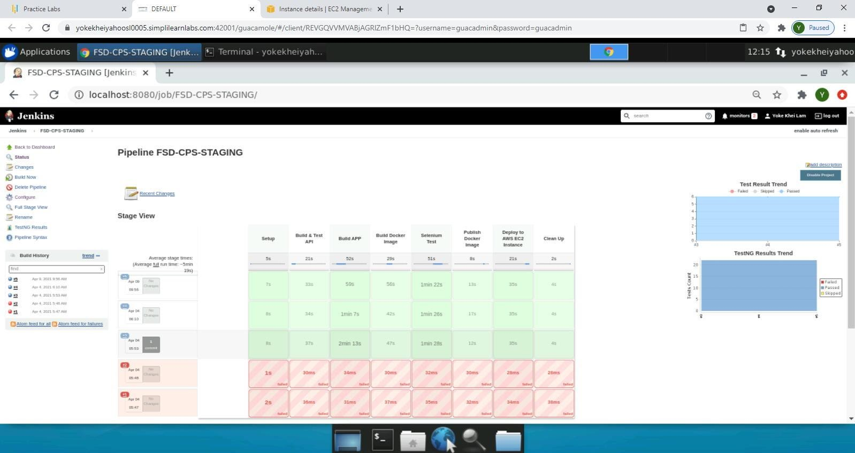

*Figure 71 DevOps - Jenkins - FSD-CPS-STAGING Job Run (Build#5)*

*Figure 72 DevOps - Git Tagging*